1) Create one VPC, with 1 public subnet and 1 private subnet.

Vpc creation:

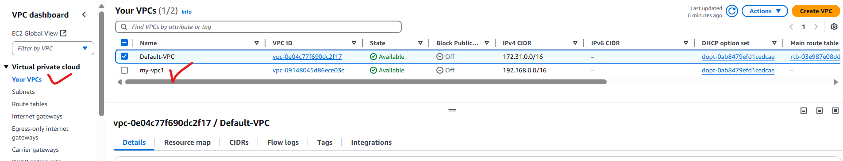

Creating 1 public subnet and 1 private subnet:

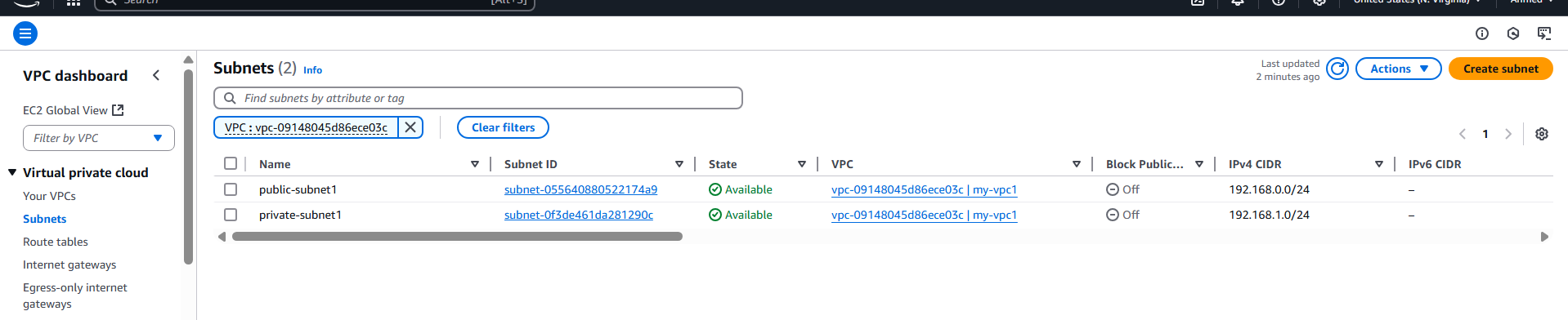

2) Enable VPC peering for cross region.



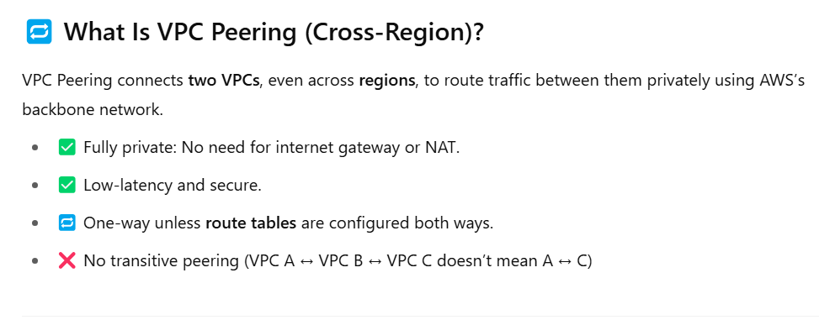

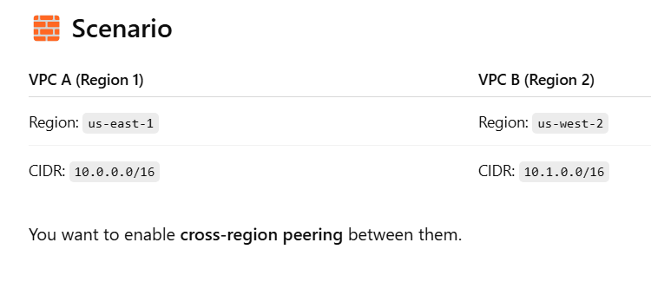

192.168.0.0/16

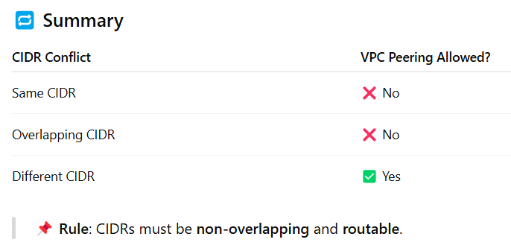

VPC-A:

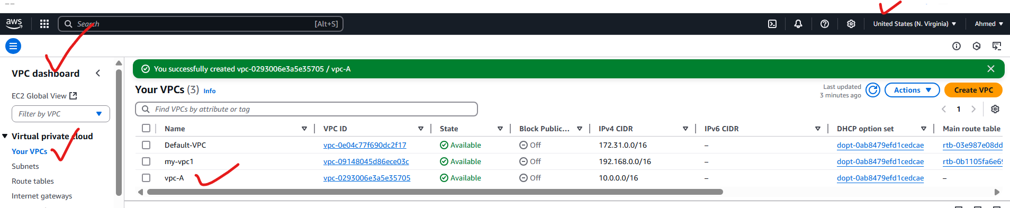

VPC-B:

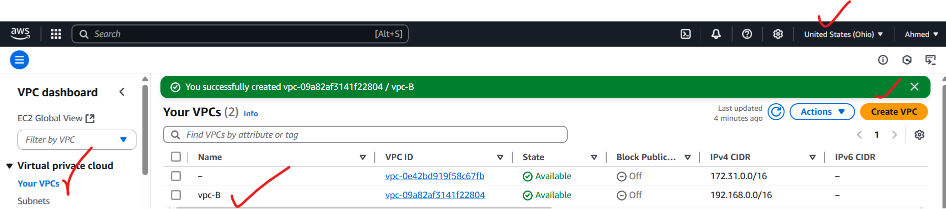

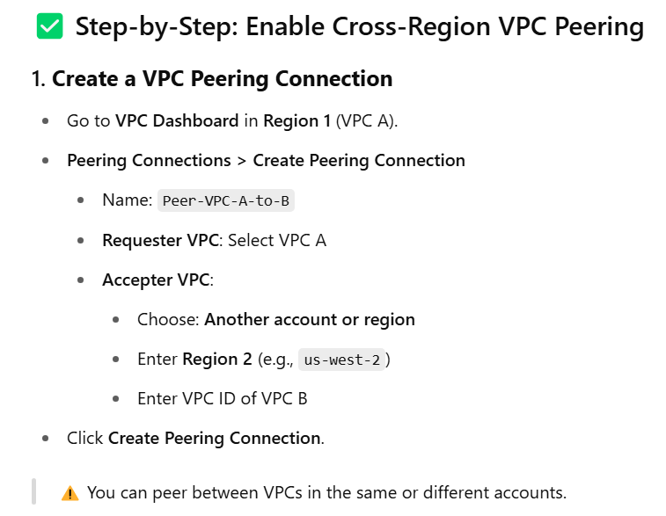

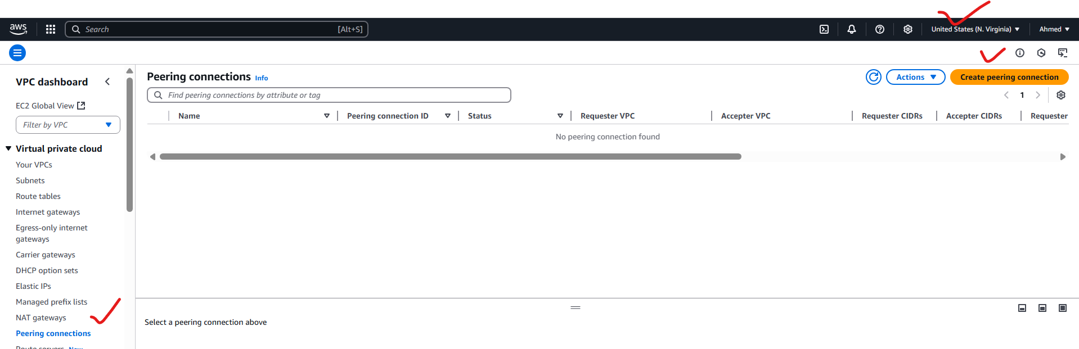

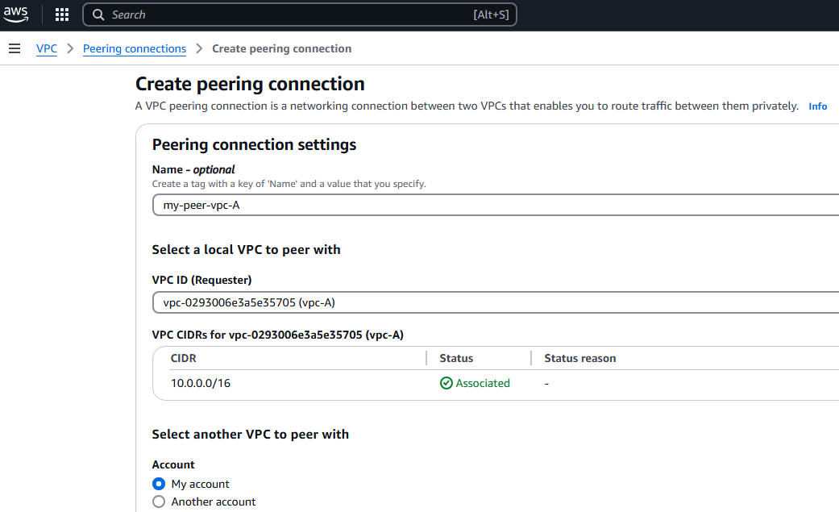

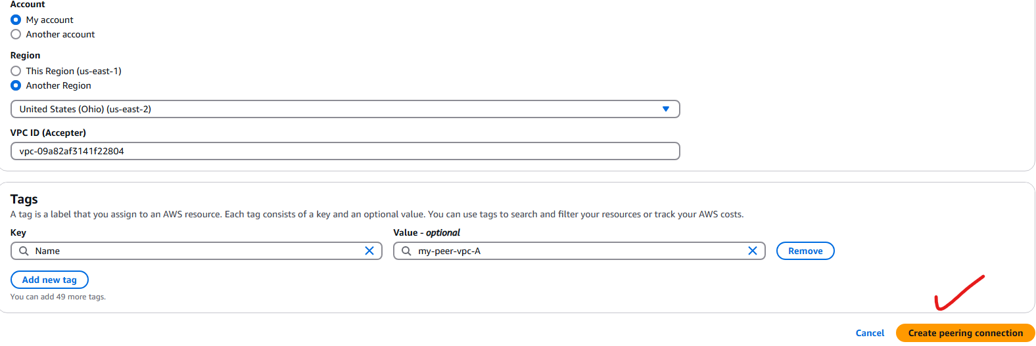

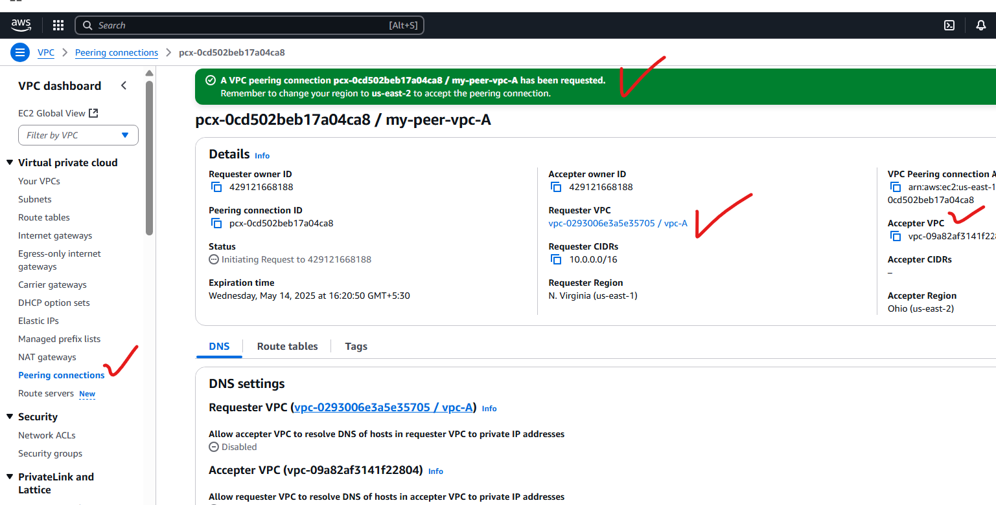

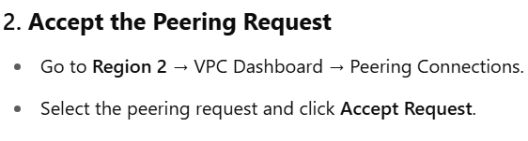

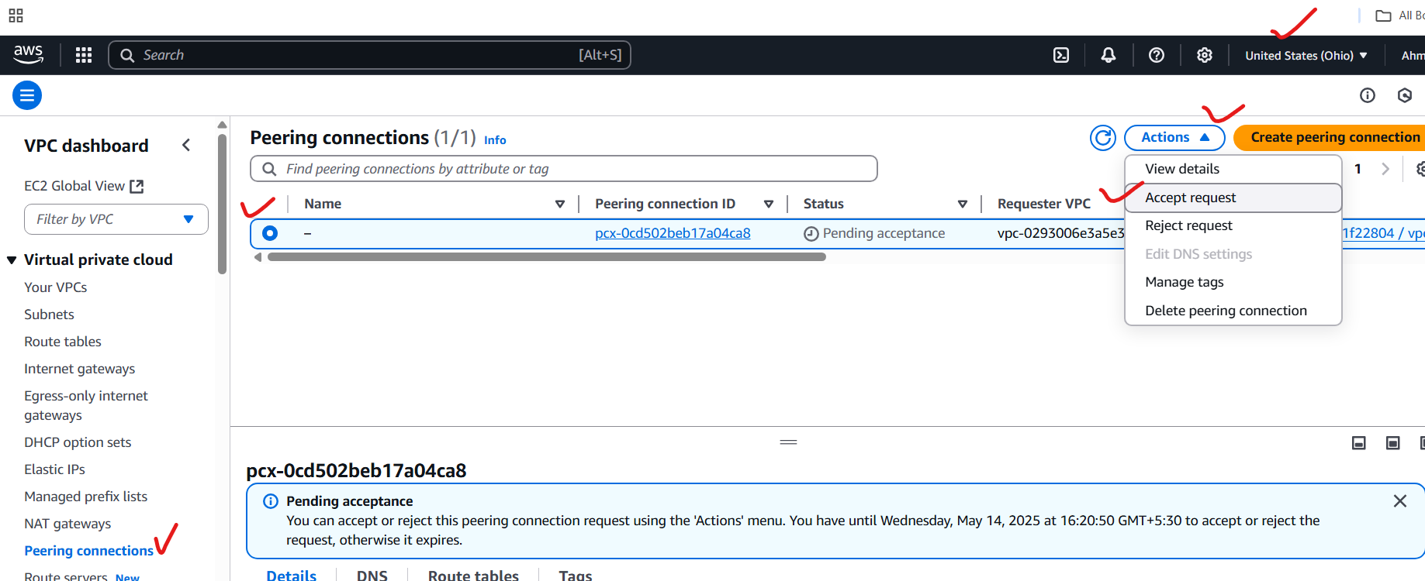

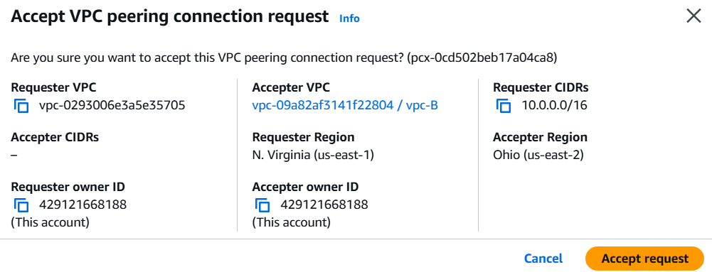

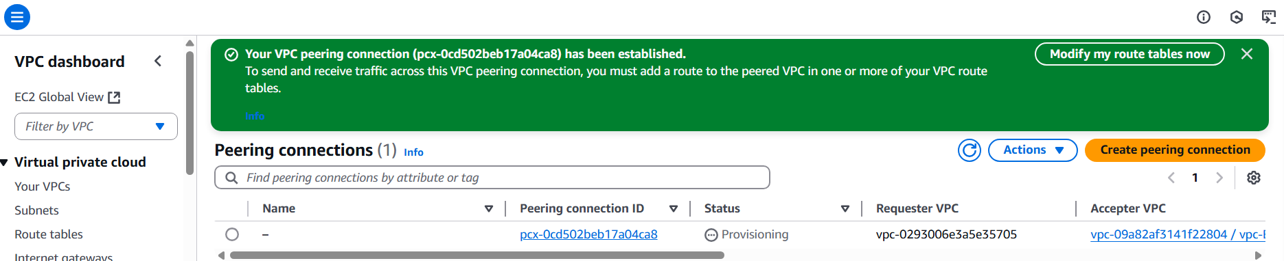

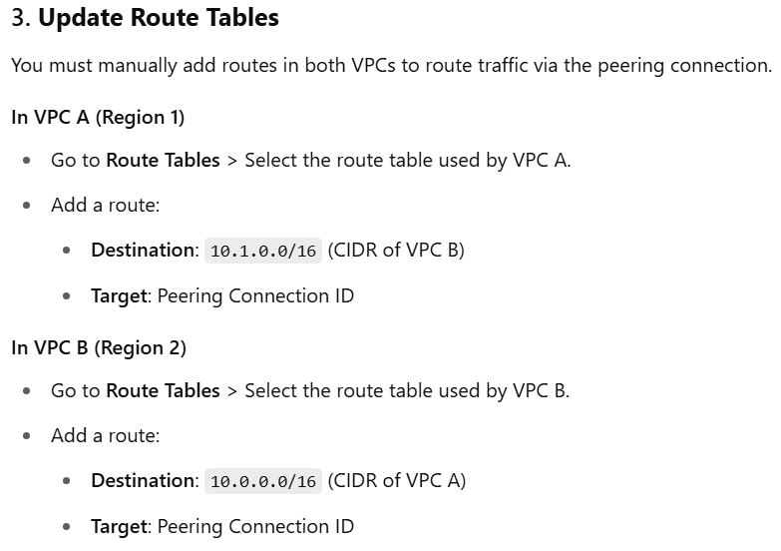

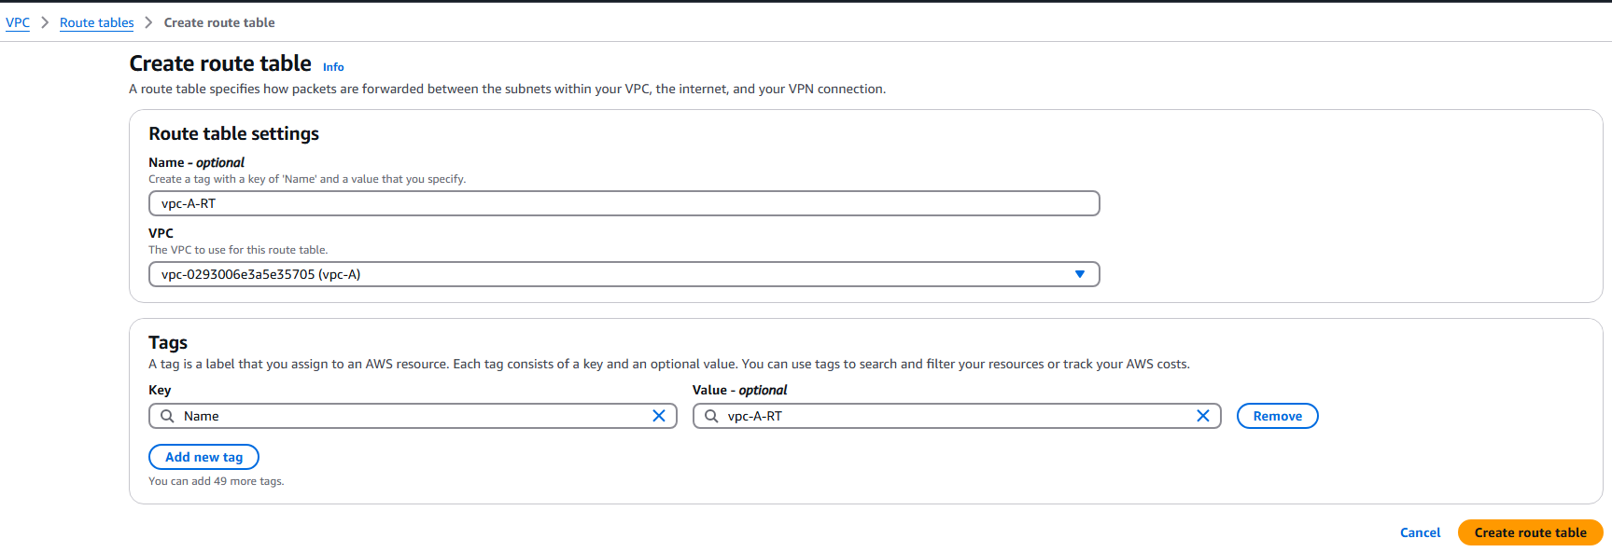

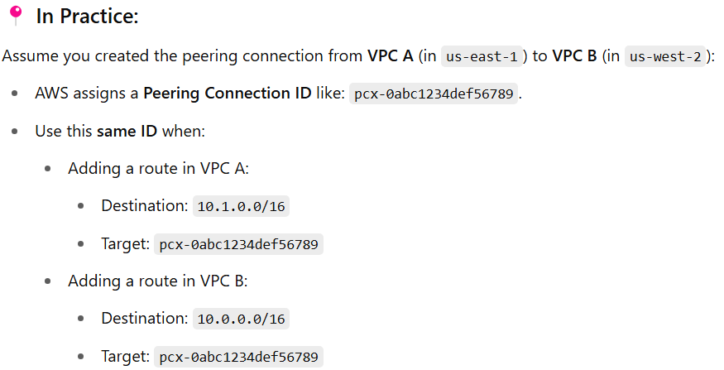

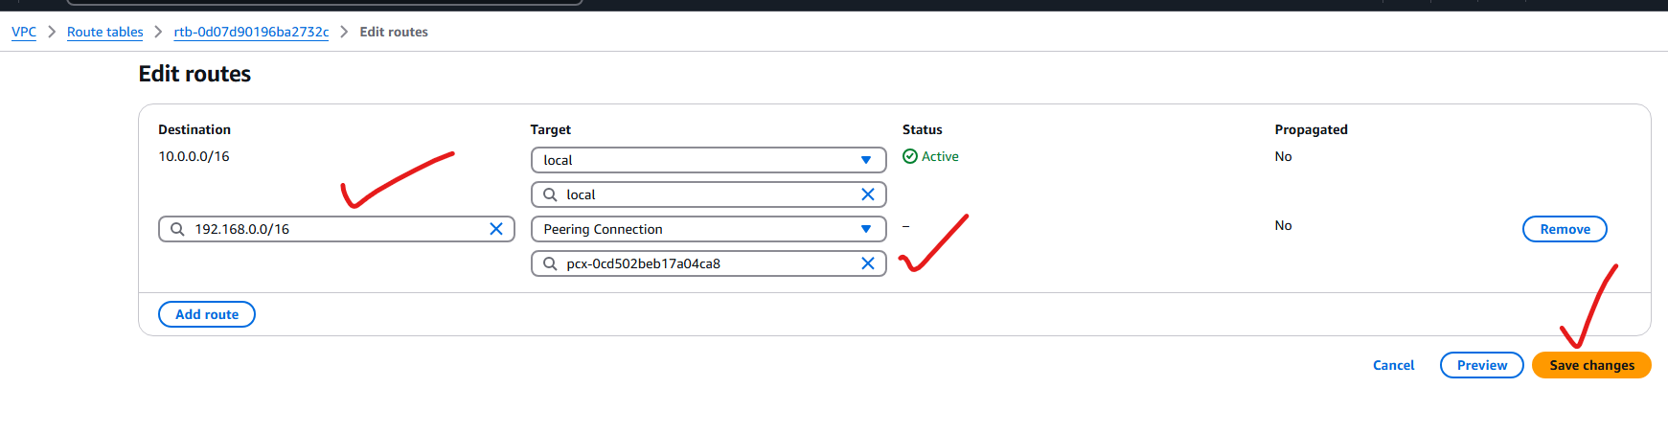

VPC-B-RT:

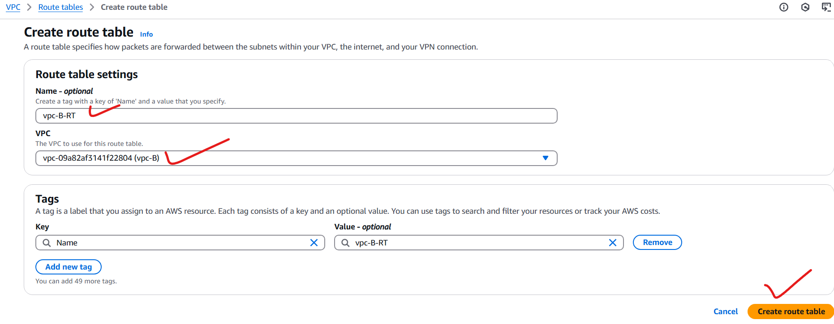

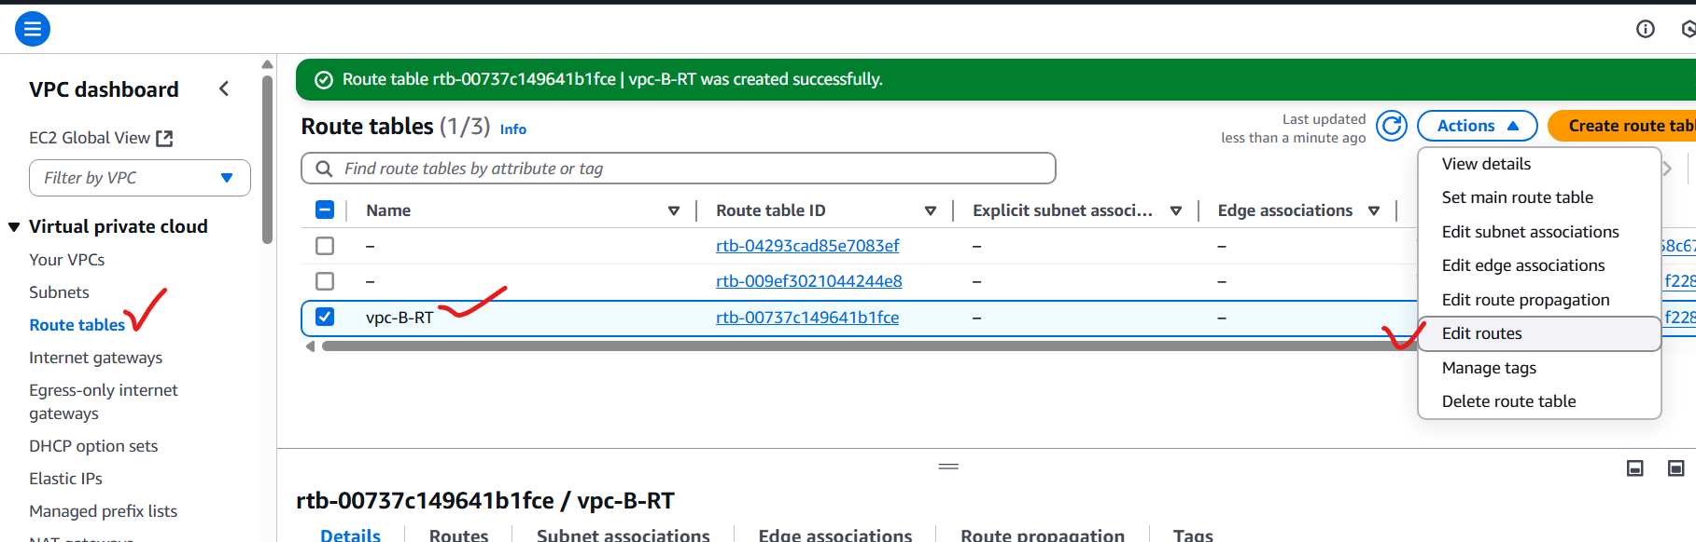

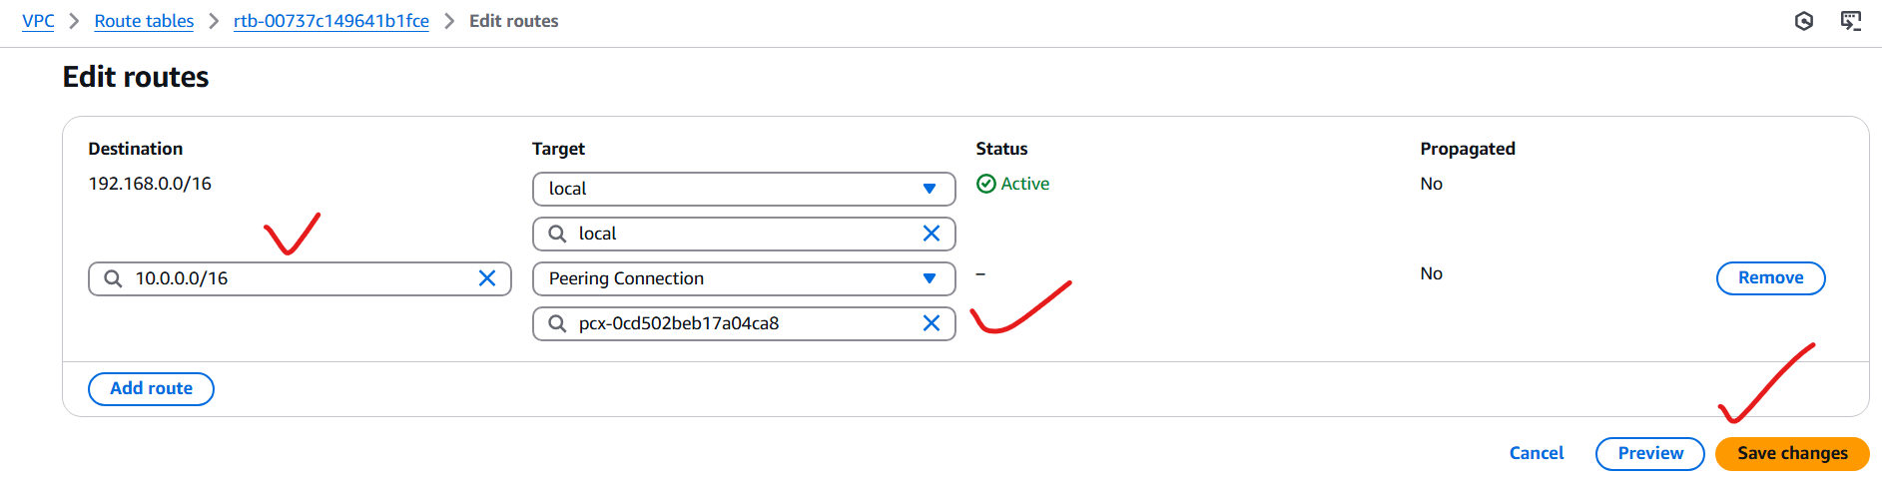

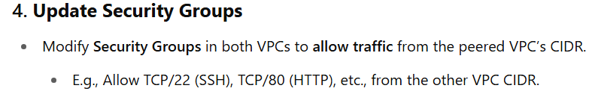

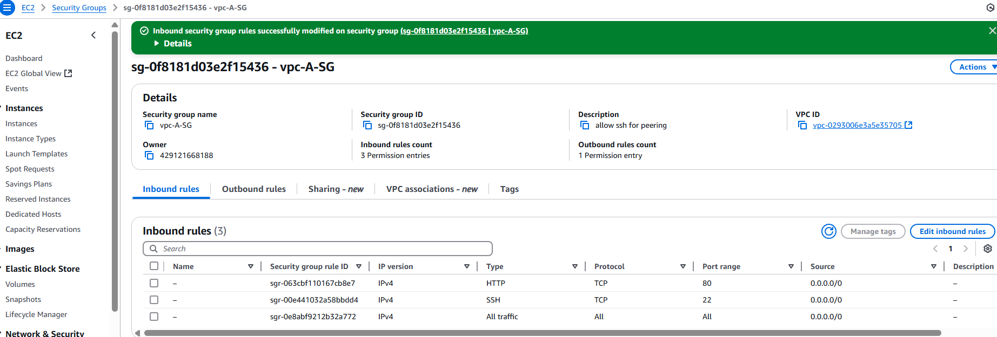

VPC-A-instance:



Vpc-A-SG:

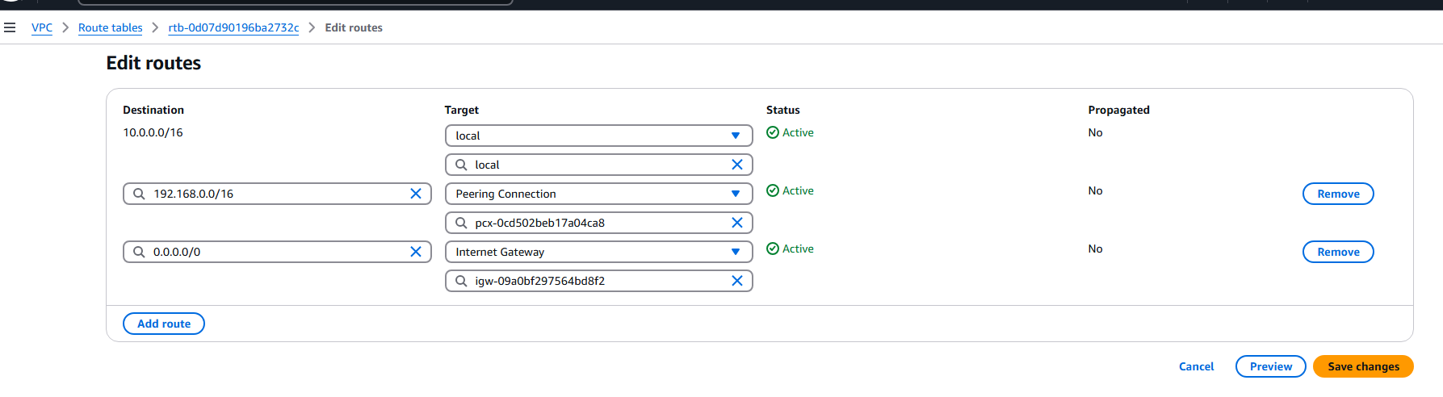

VPC-A-RT:

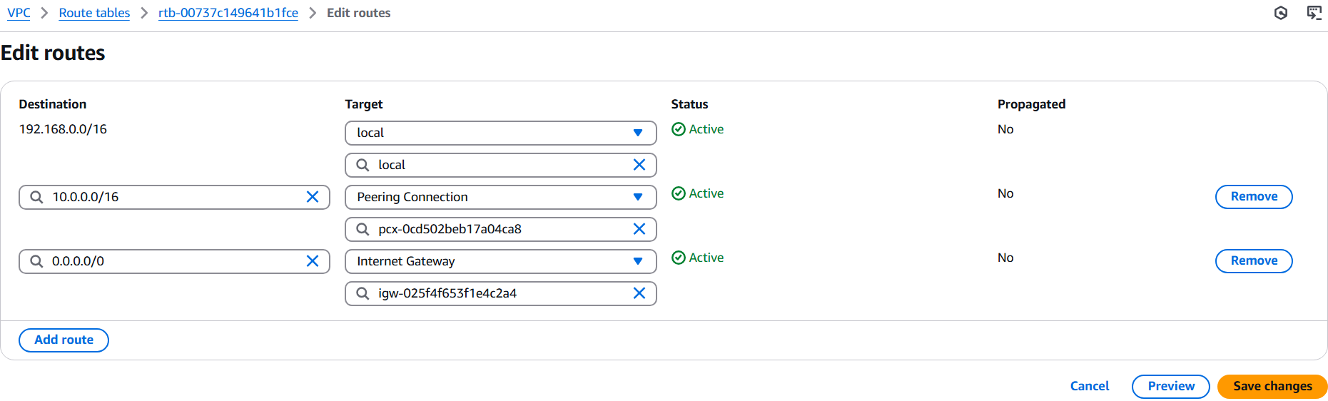

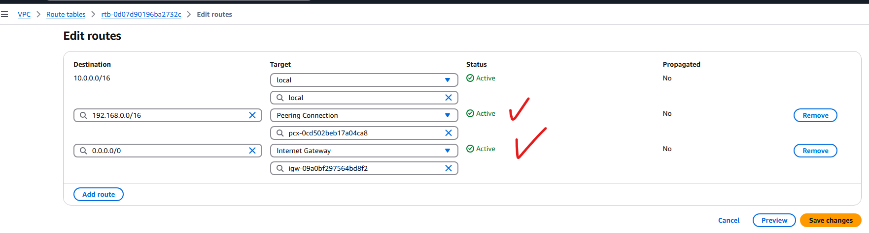

Vpc-B-SG:

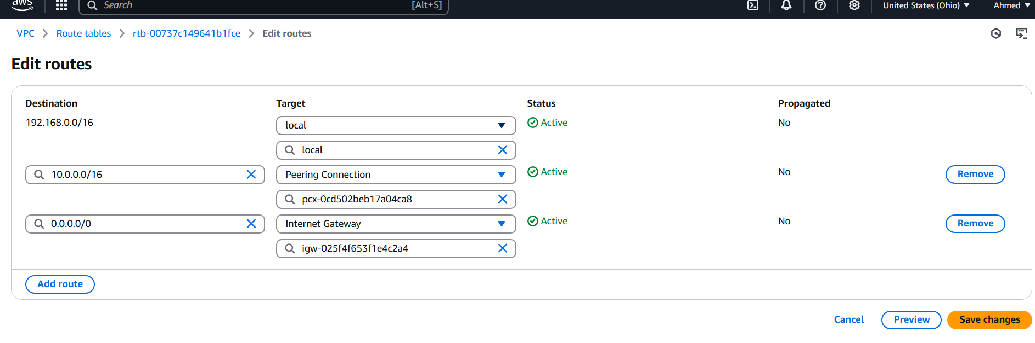

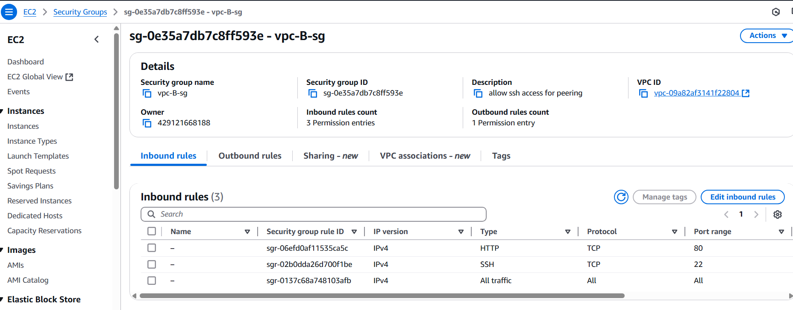

VPC-B-RT:



Pinging VPC-A to VPC-B:

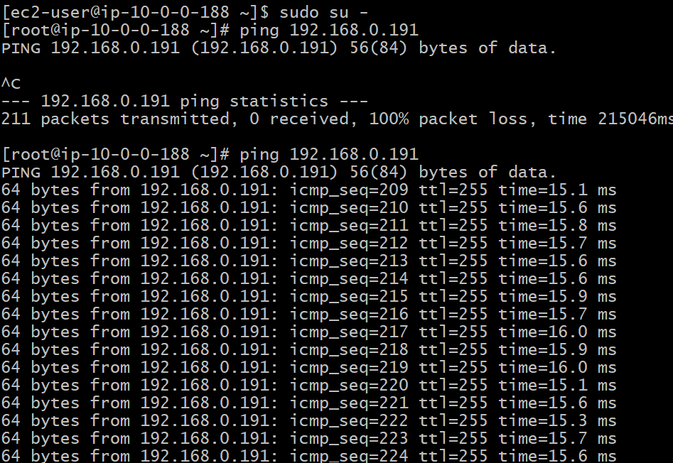

Pinging VPC-B to VPC-A:

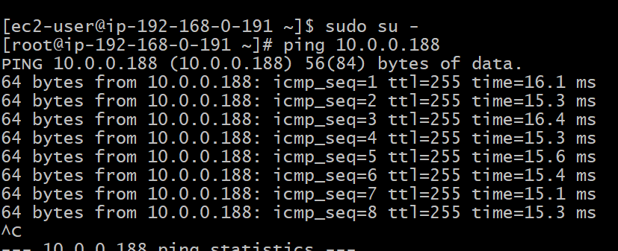

3) Enable VPC peering for cross account. (You can collaborate with your friend and do this task)

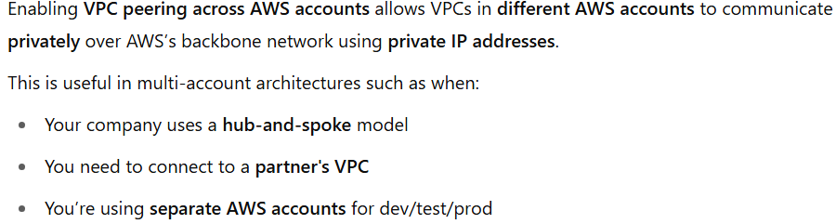

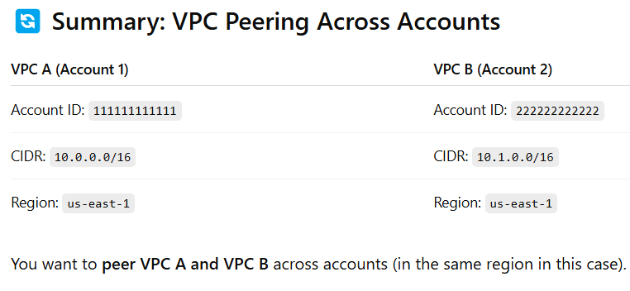

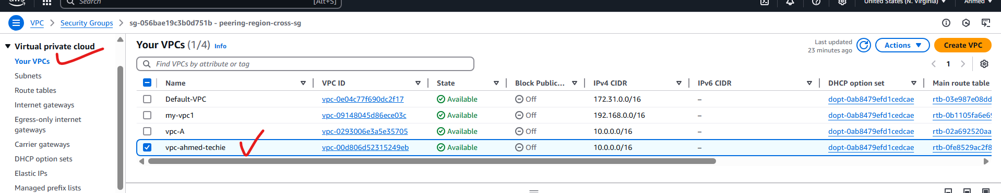

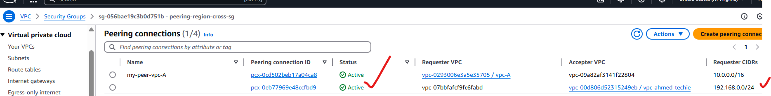

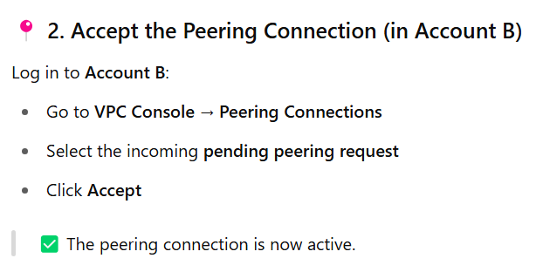

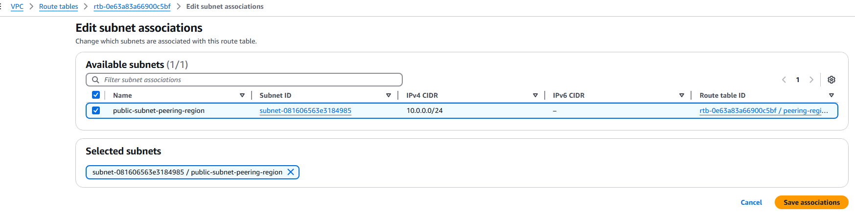

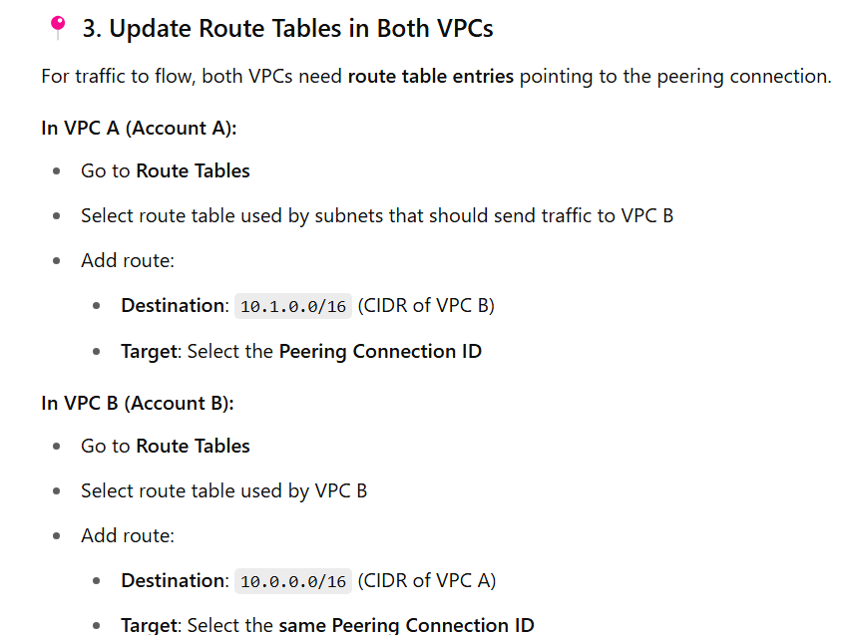

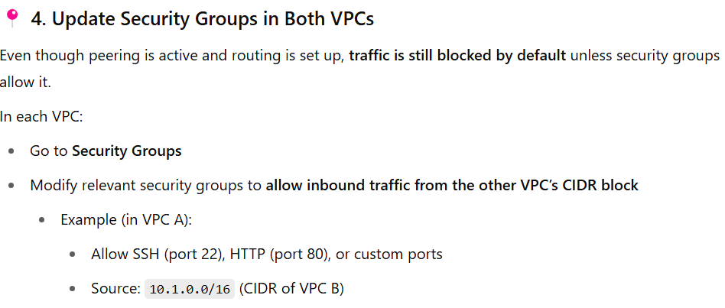

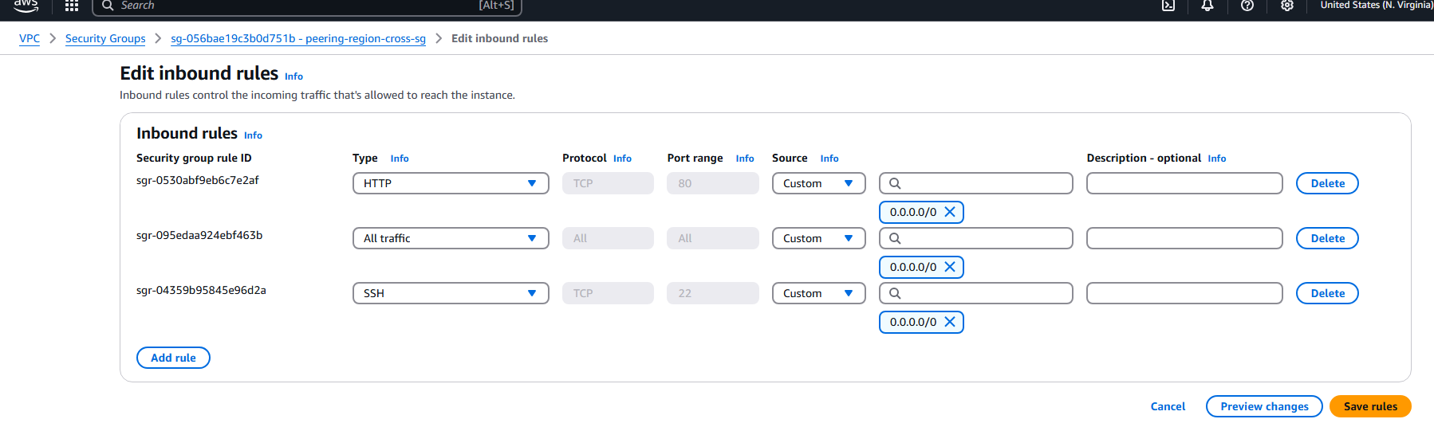

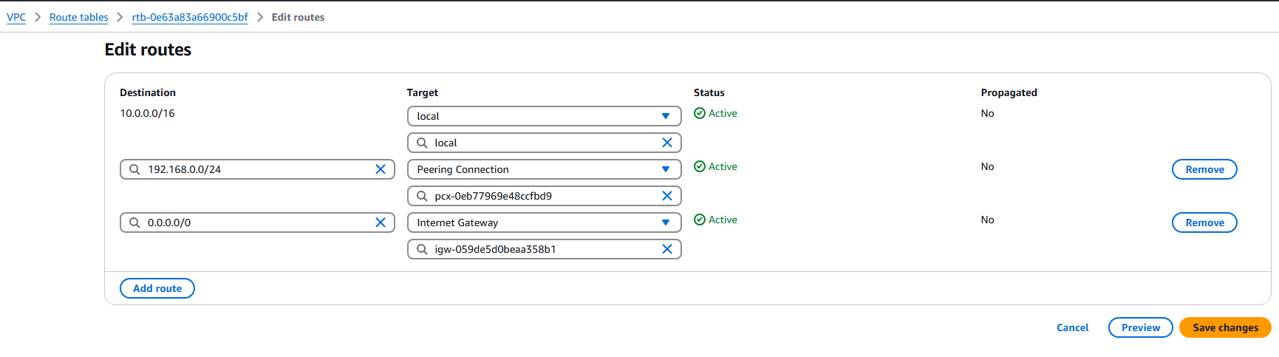

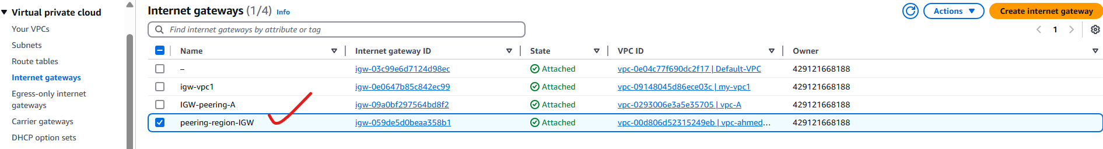

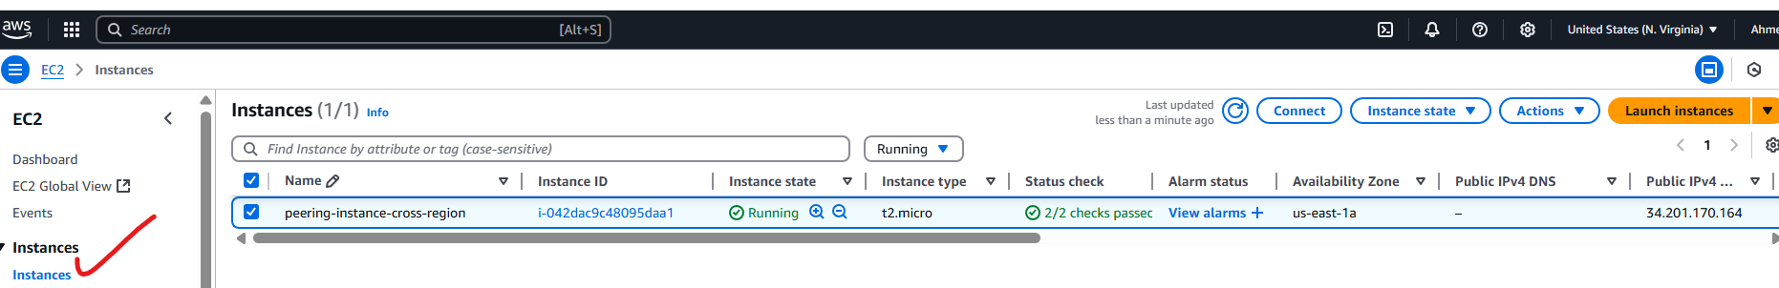

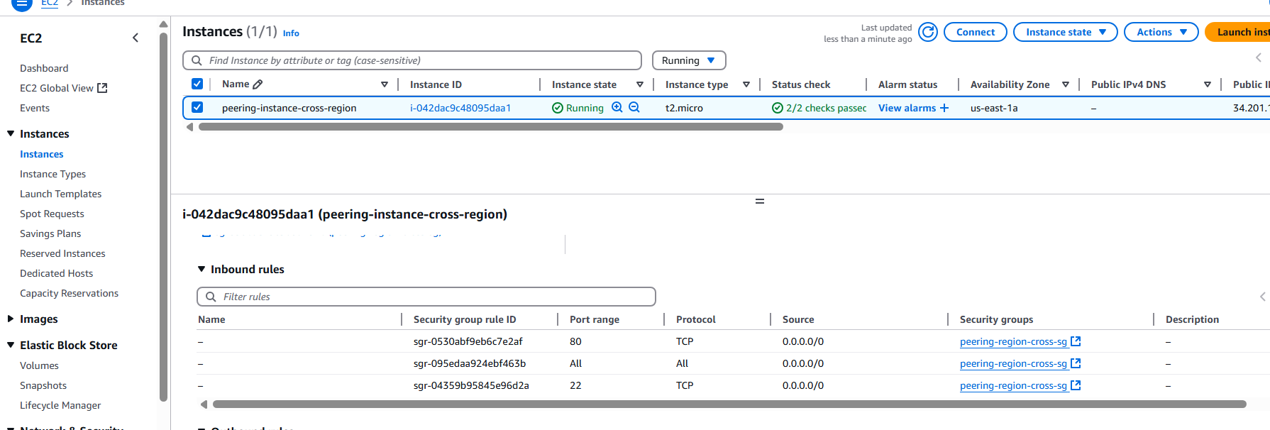

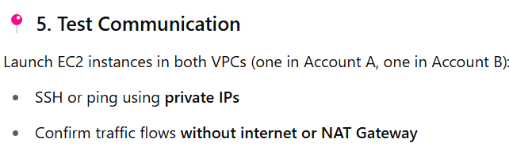

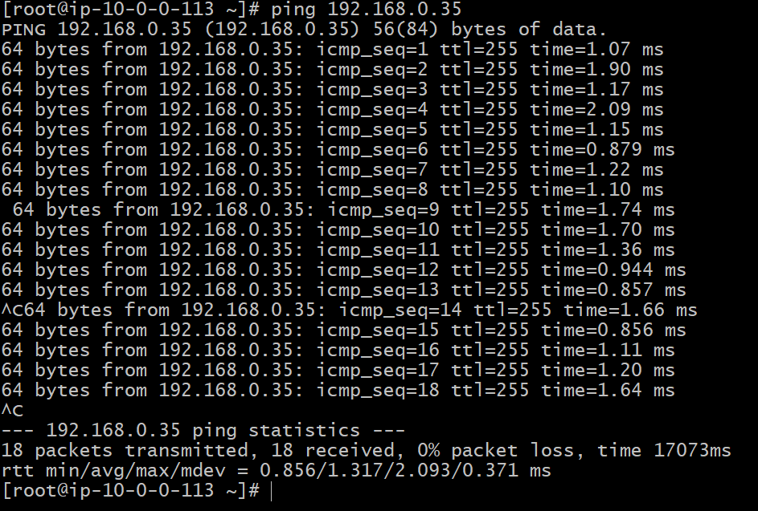

4) Setup VPC Transist gateway.

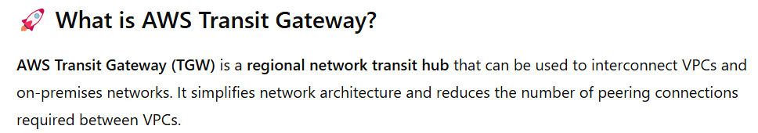

Let us create 4 VPC:

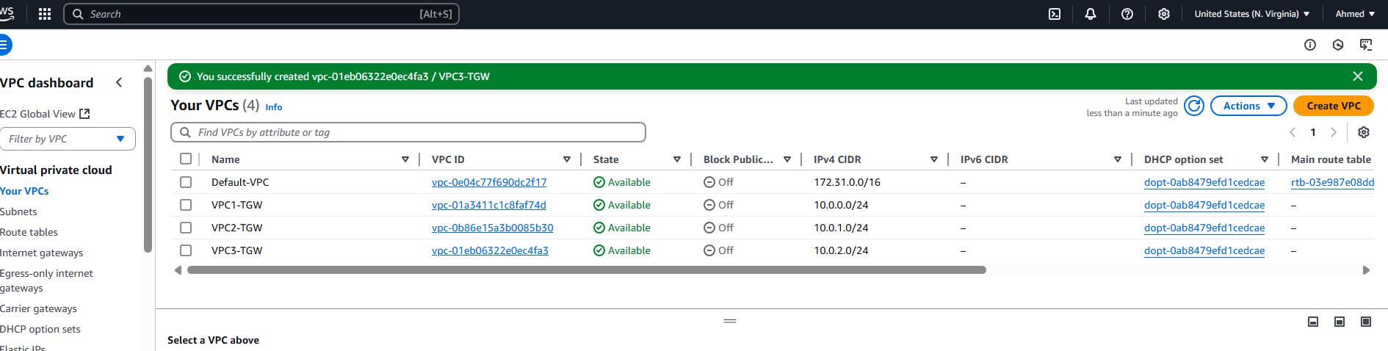

Created 1 public and 4 private subnets: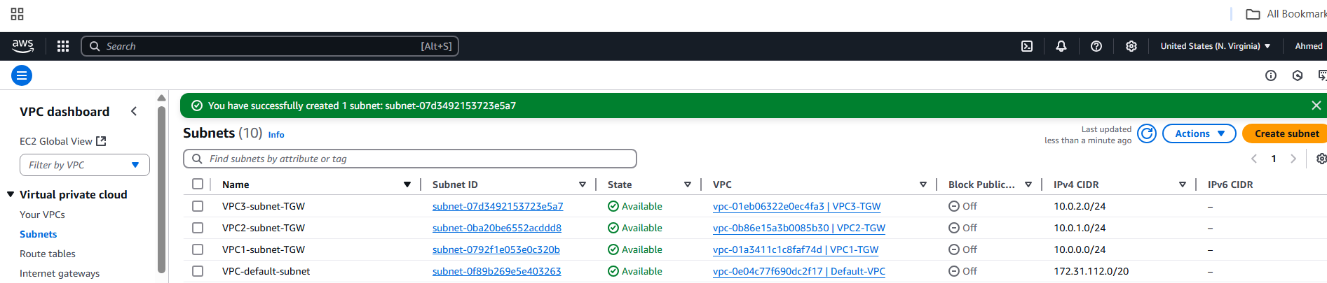

This details find for our networking team:

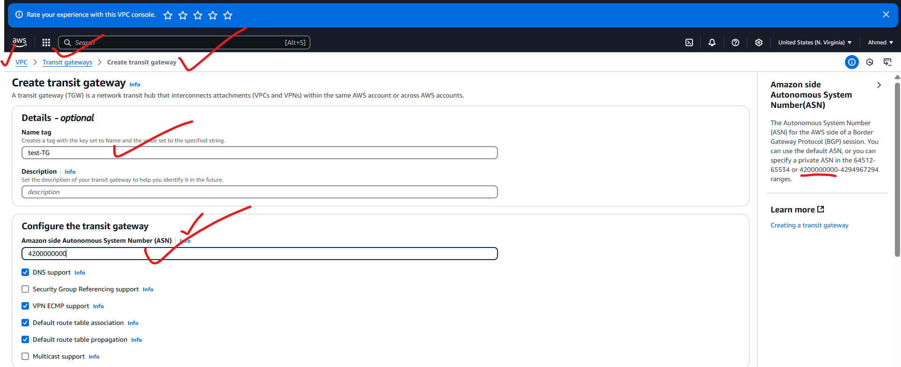

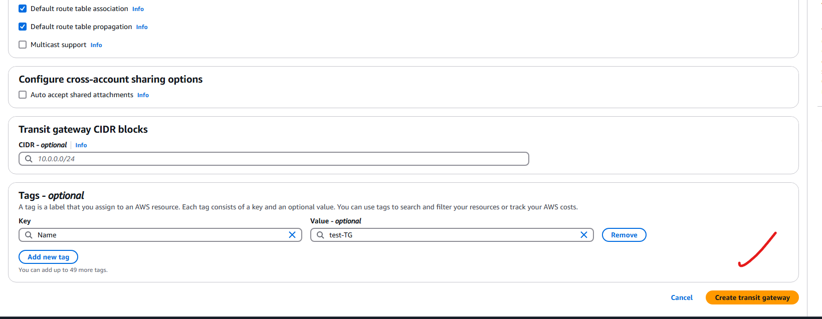

Attaching the details to transit gateway:

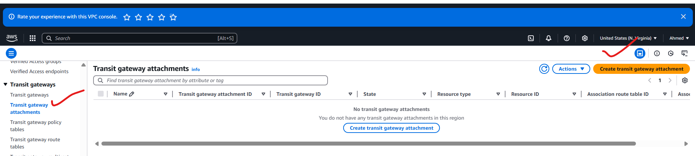

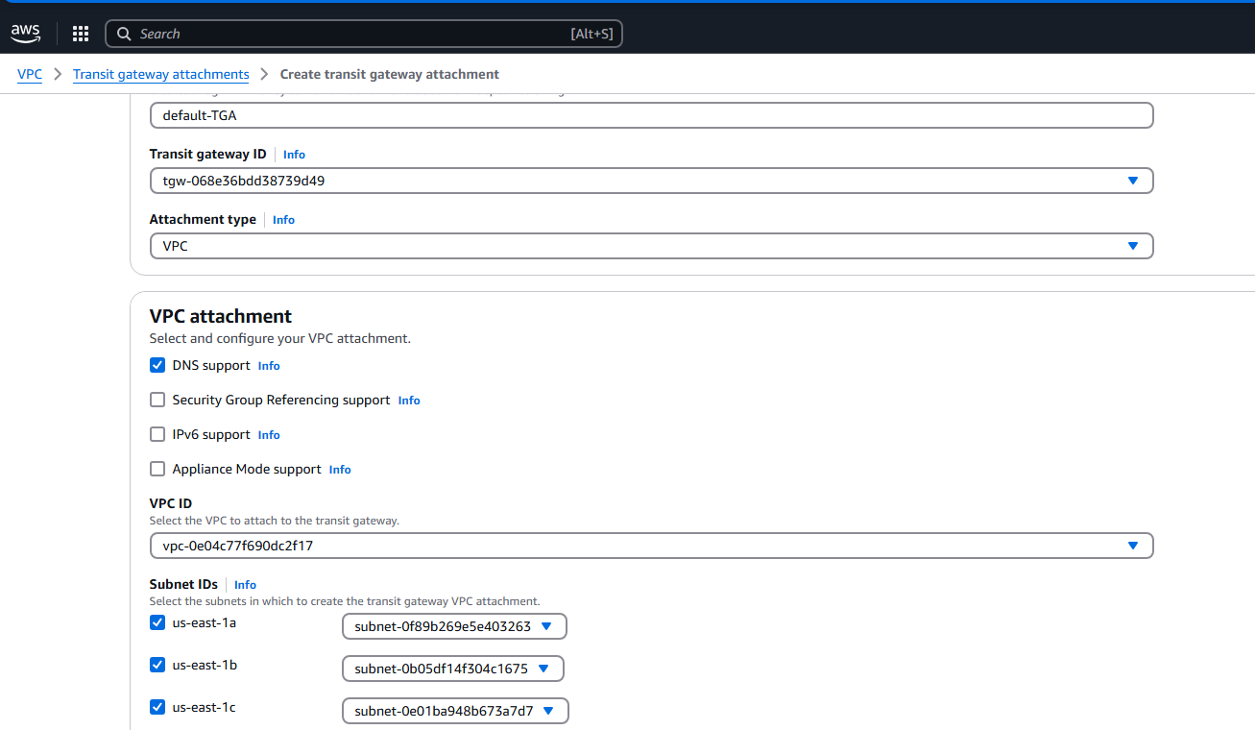



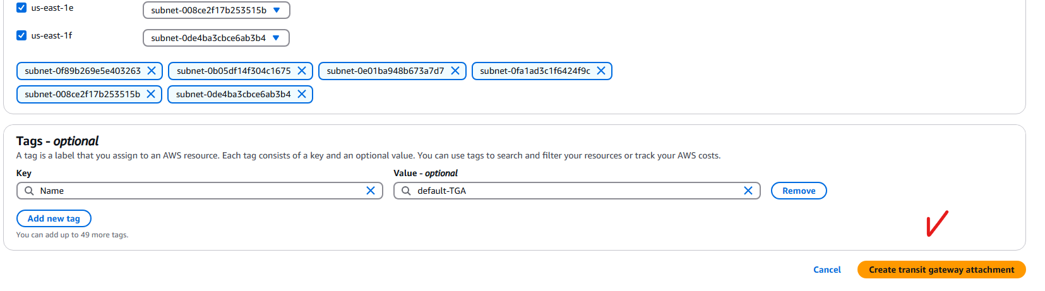

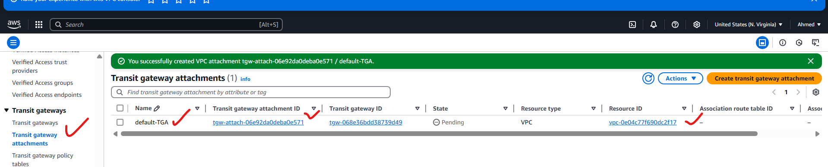

Like this we need to create transit gateway attachments for remaining VPC’s

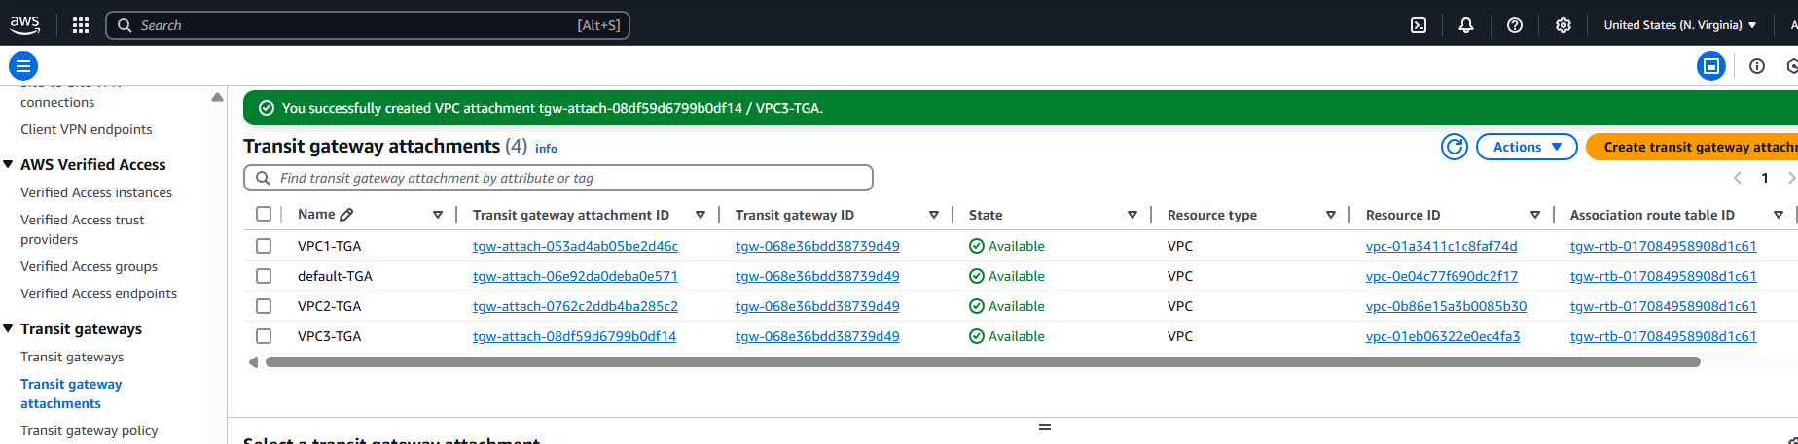

Next: transit gateway routing table will create automatically with all the VPC details

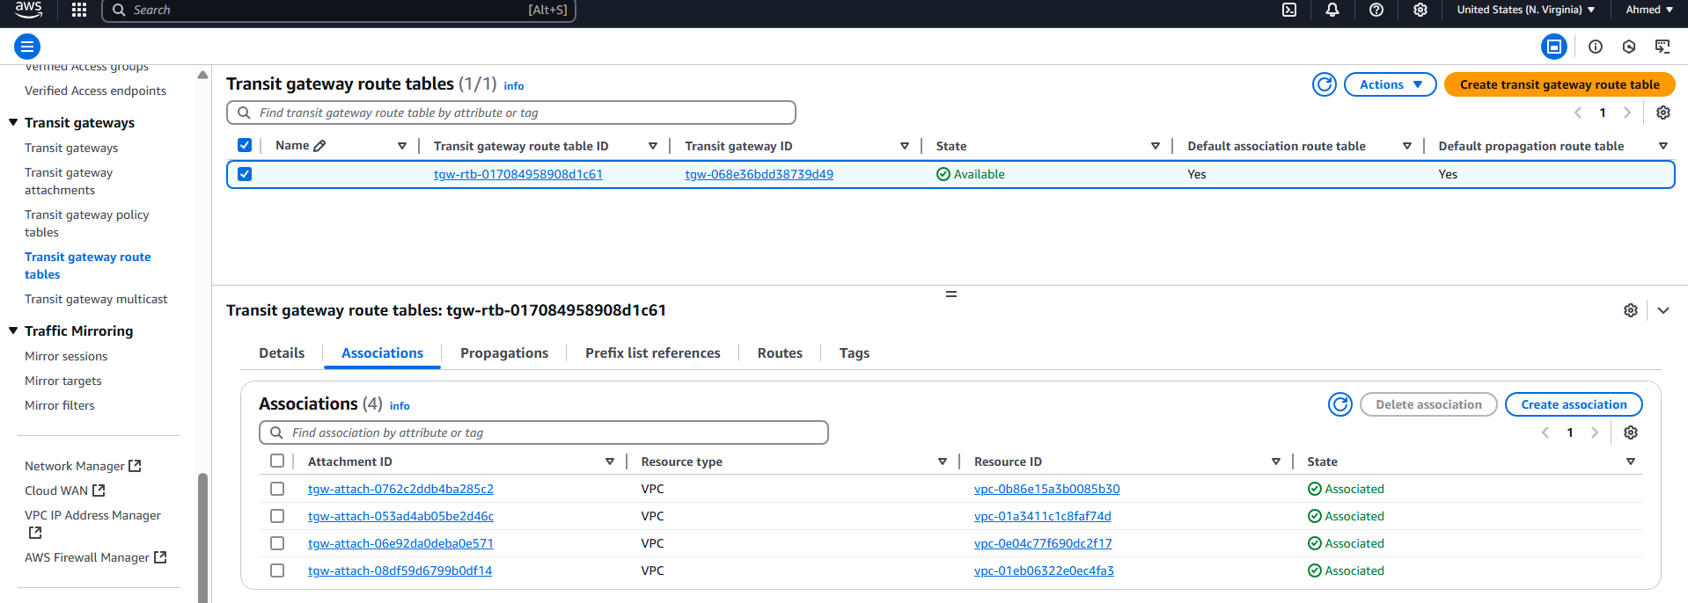

Now I will create 4 instances in 4 VPC’s:

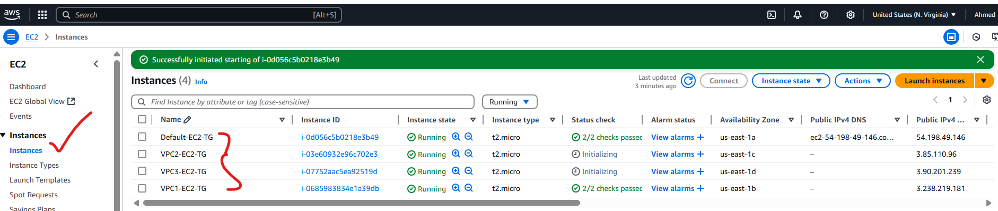

Now connect with the default VPC ec2 instance:

Now I am trying to connect from my default-VPC-EC2 to VPC1-EC2 instance by using its private ip-address, but it is not pinging.

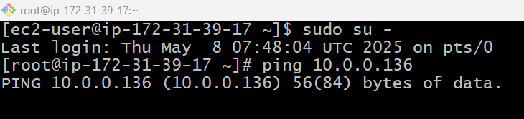

Because we haven’t mention our VPC’s where this traffic needs to be redirected. That’s the reason it is not responding/pinging

VPC🡪Routs🡪Edit Routs:

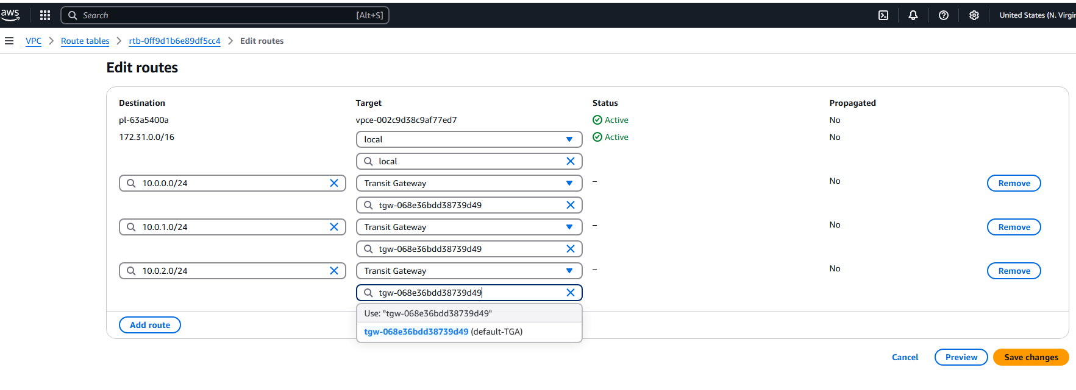

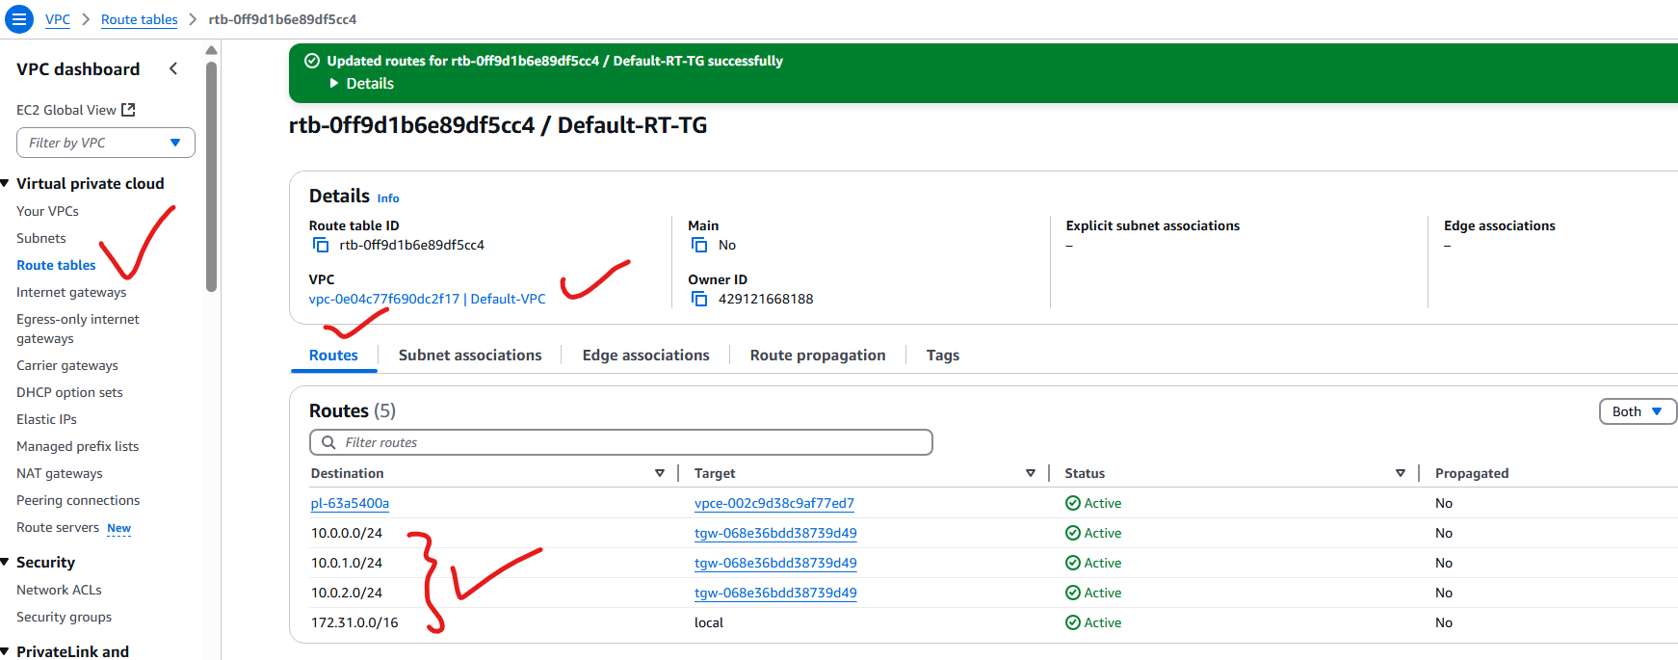

On VPC1-TG:

Route:

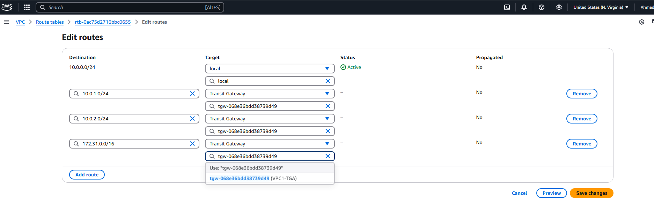

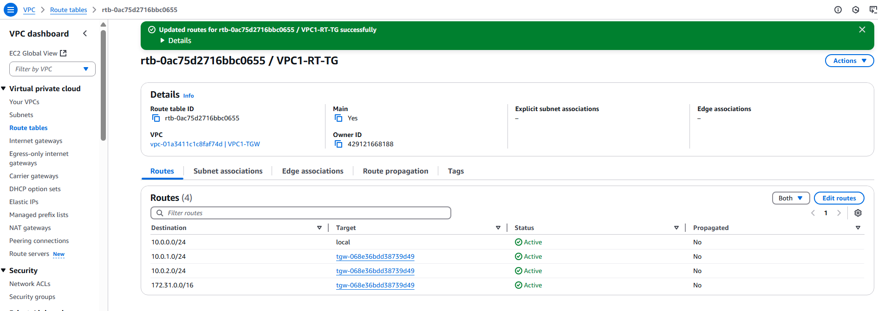

On VPC2-TG:

Route:

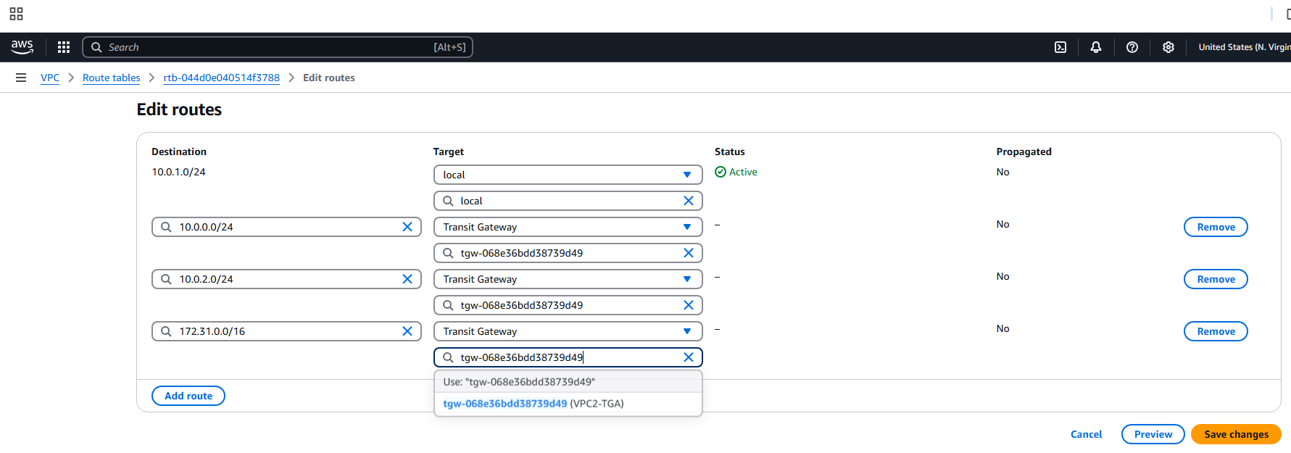

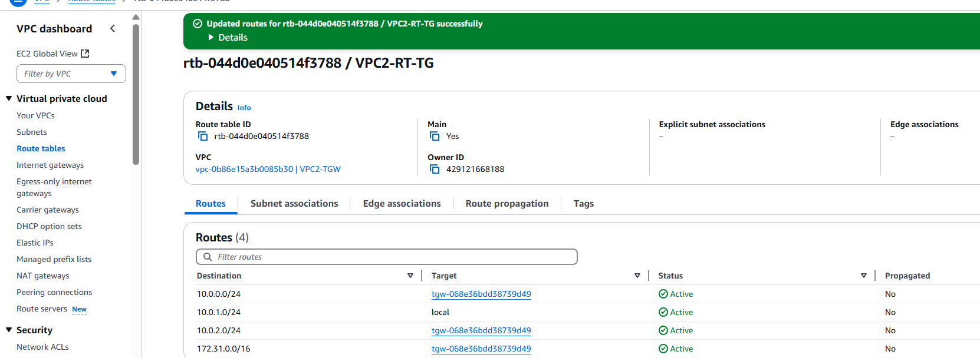

On VPC3-TG

Route:

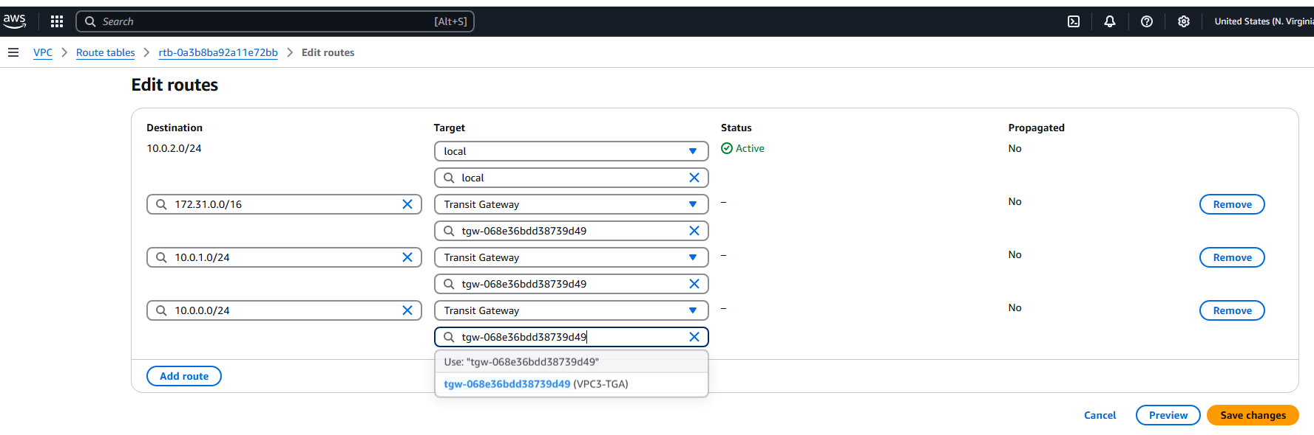

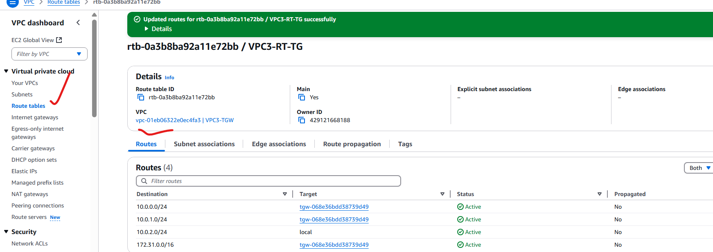

Still it is not working why?

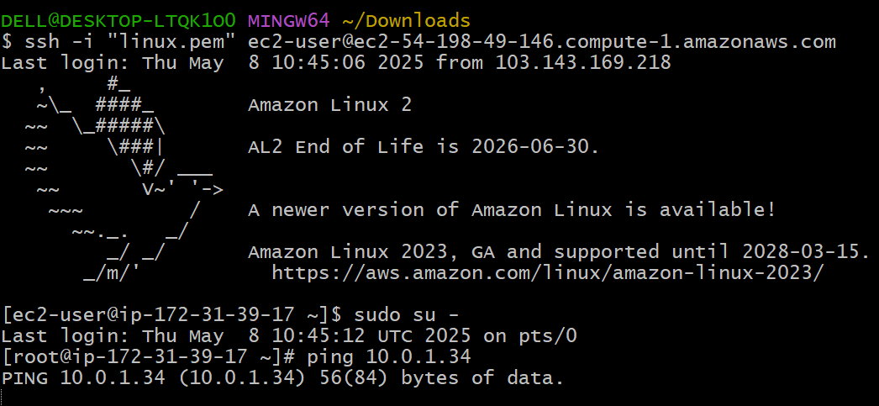

Because we are not updated Internet Gateway to the routing table:

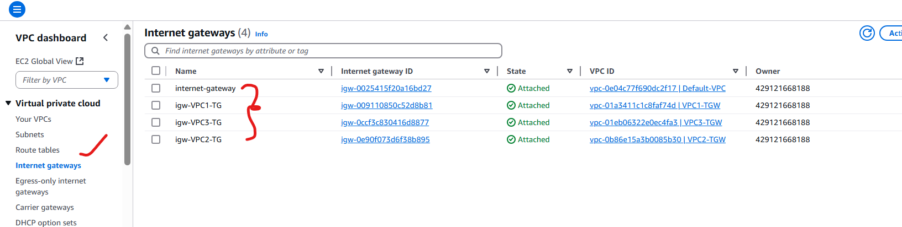

Like this we need to attach all the targets In route table:

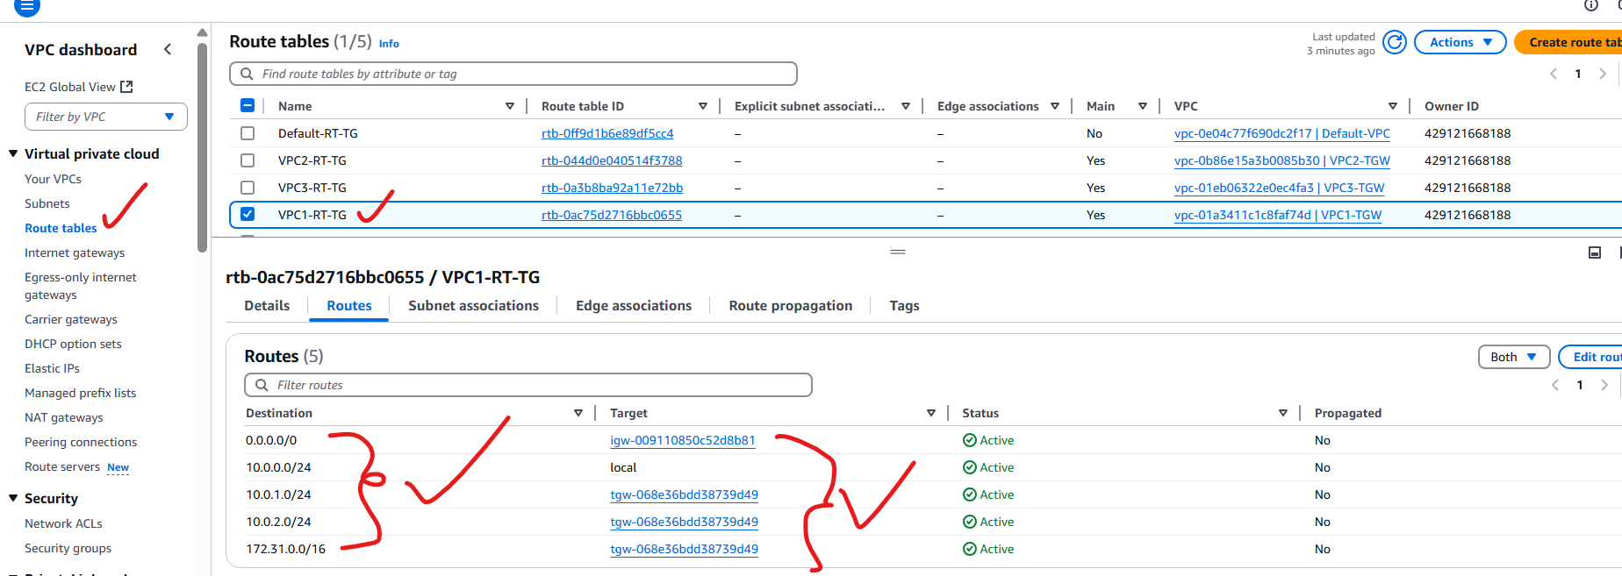

Still not connected:

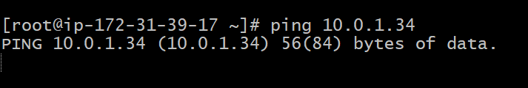

We need to allow traffic from security groups: like this we need to give in all the ec2-instances security groups.

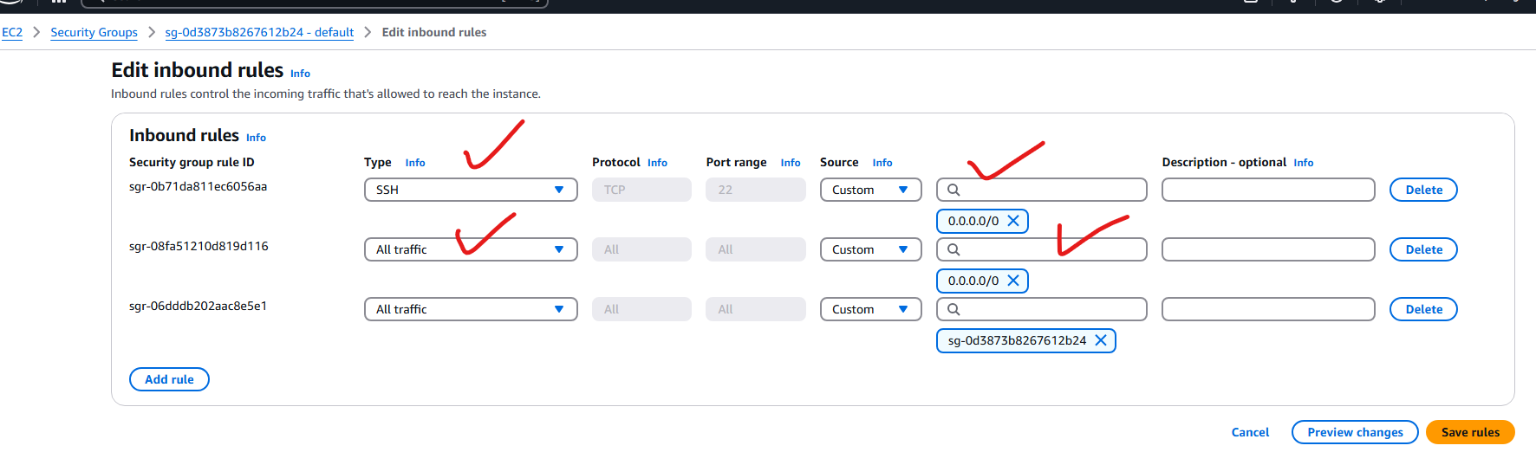

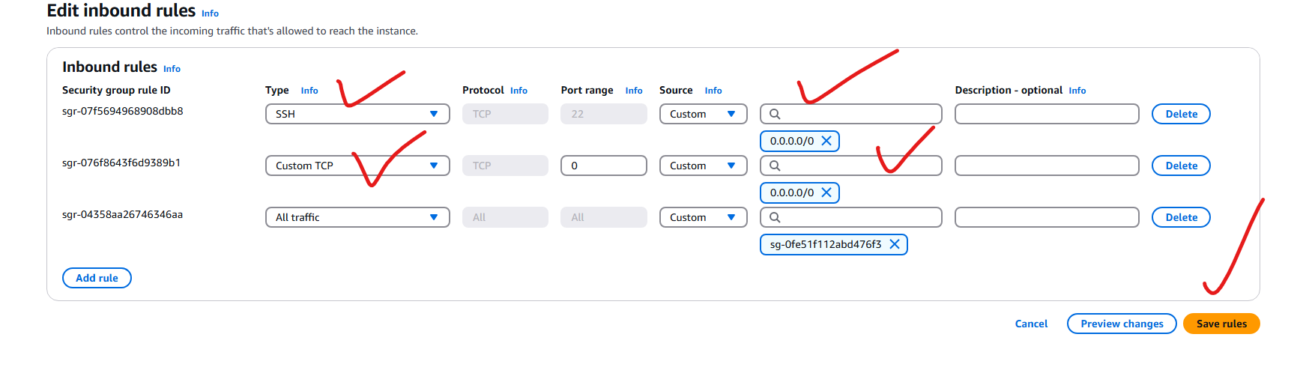

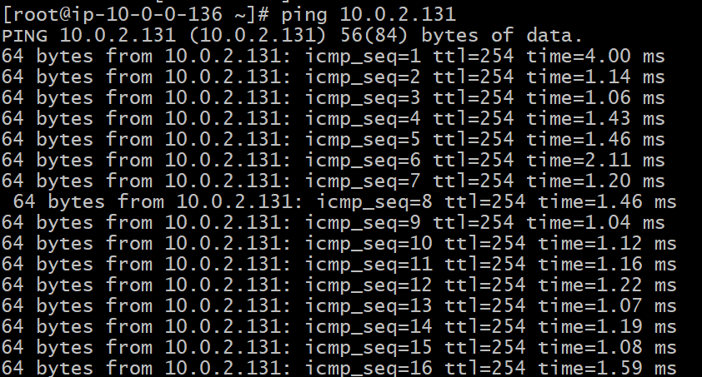

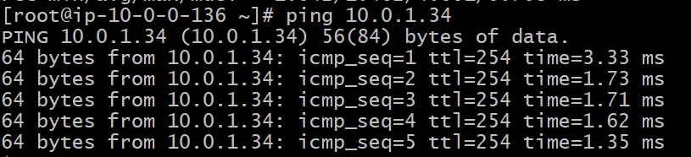

5) Setup VPC End Point.

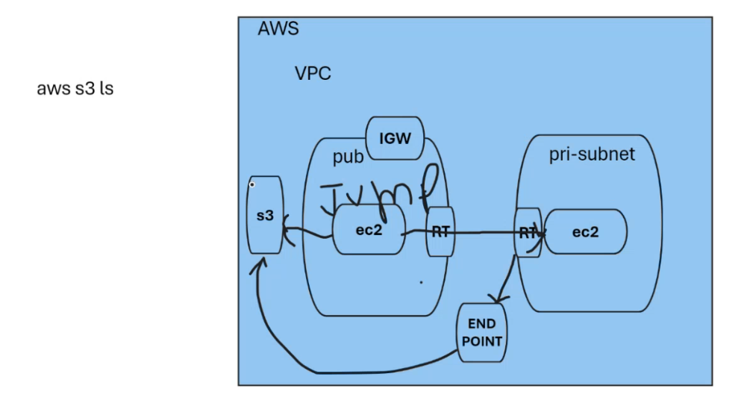

Create a VPC or take Default VPC:

Here I selected default vpc:

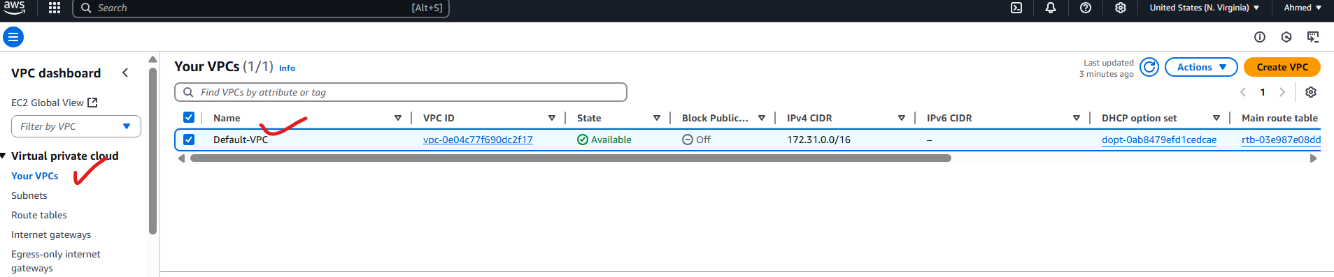

Create 2 subnets:

1. public subnet

2. private subnet

For public subnet I selected default subnet, and for private subnet I created it.

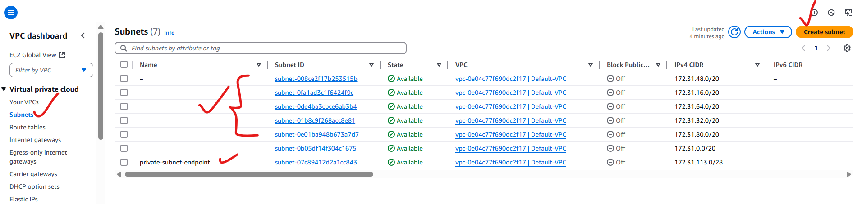

Create Route table for public and private, and I selected public route table as default route table and for private route table I have created.

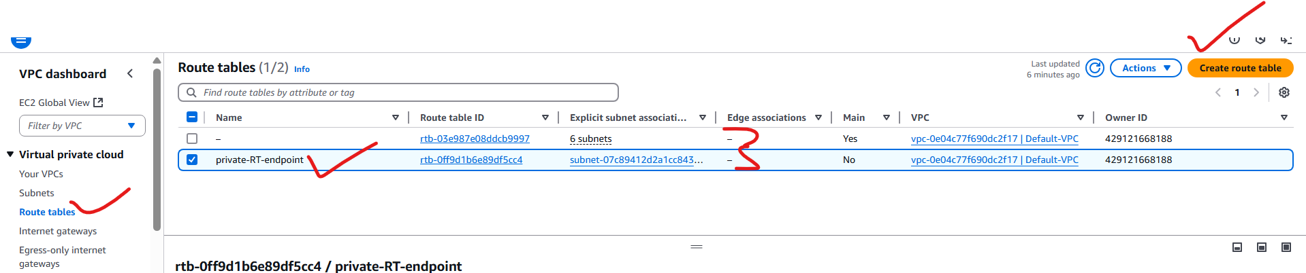

In public route table, add public subnets to association and in private route table add private subnet for association.

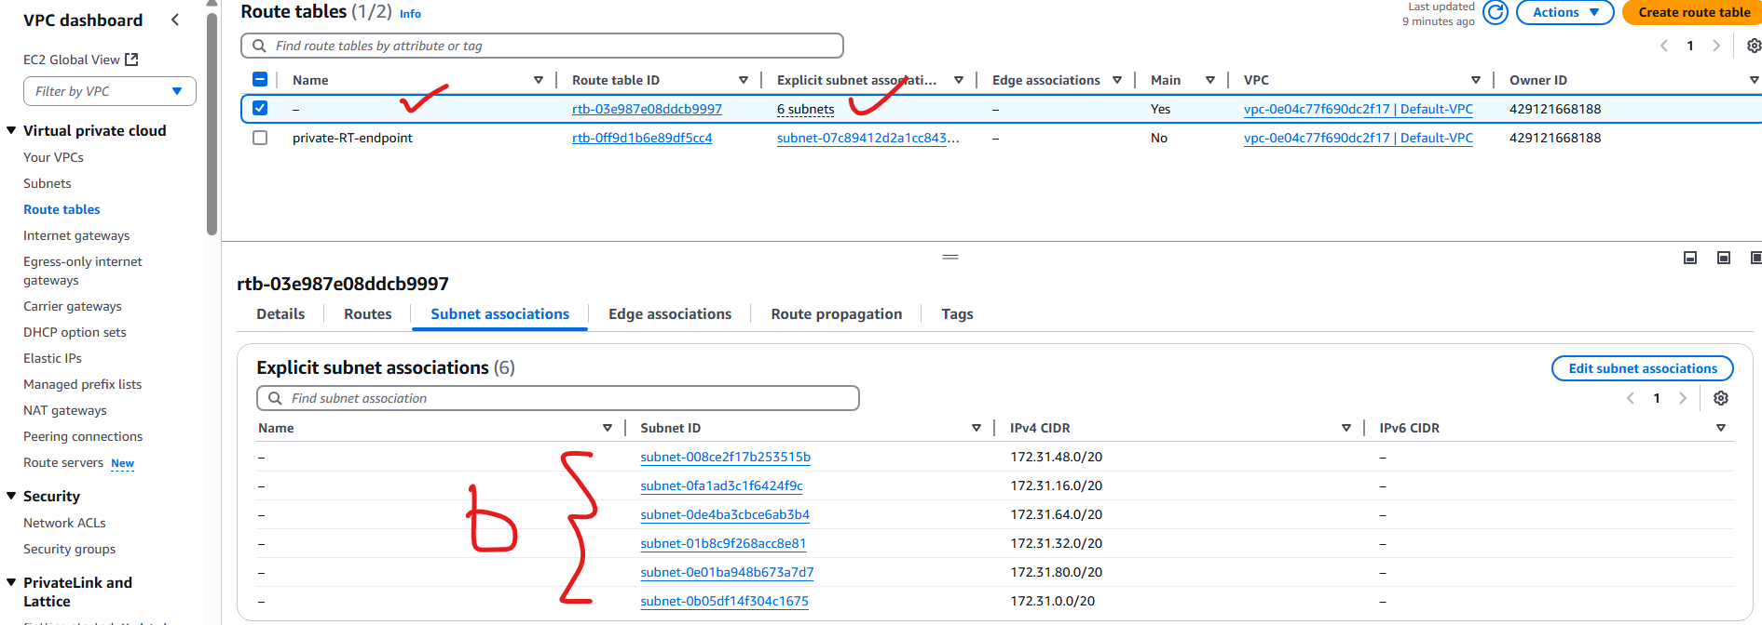

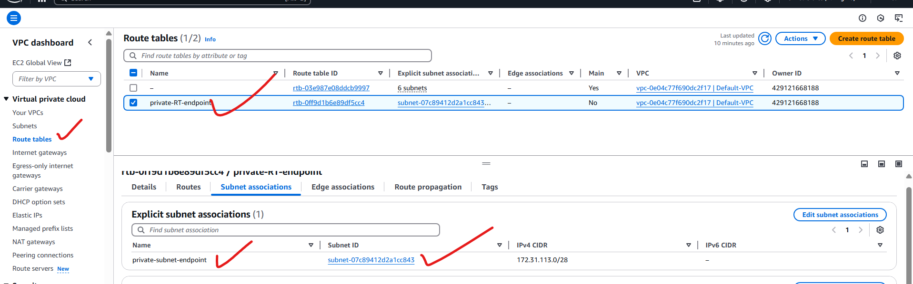

In public route table, add internet gateway and in private route table don’t add internet gateway or NAT gateway.

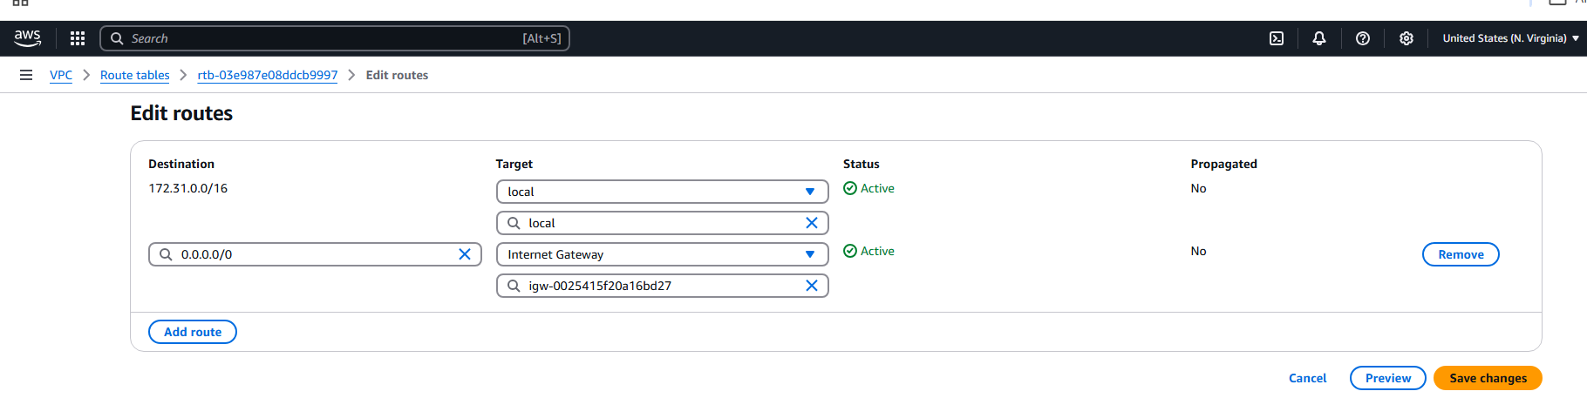

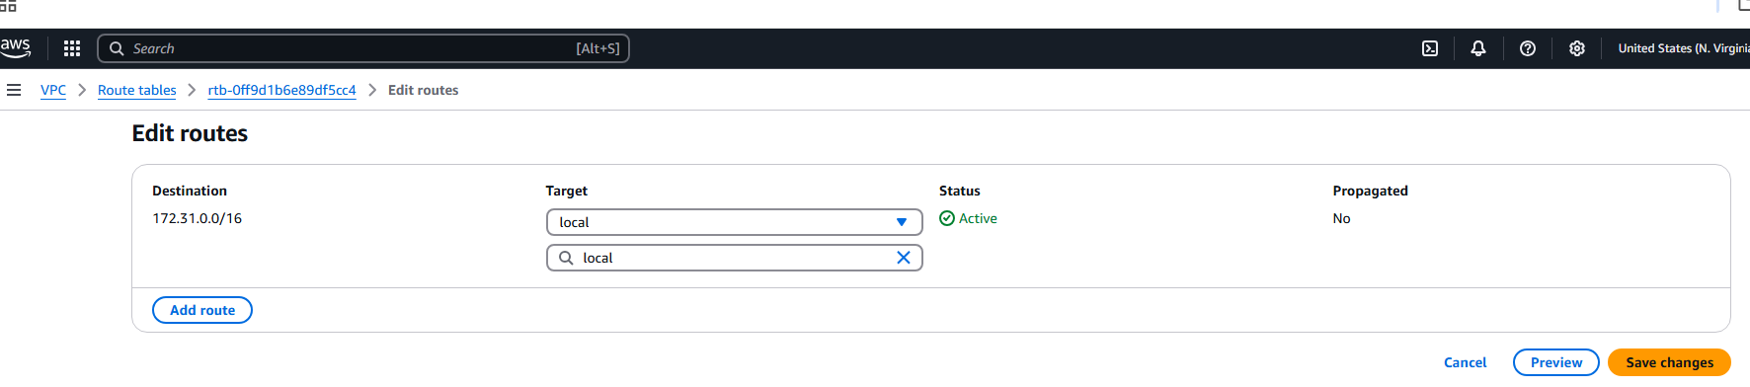

Now create 2 instance:

1. public instance

2. private instance

Public instance:

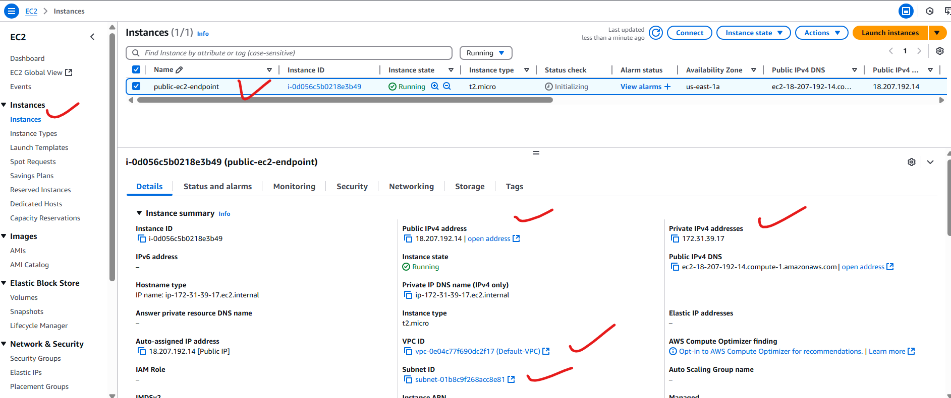

Private instance:

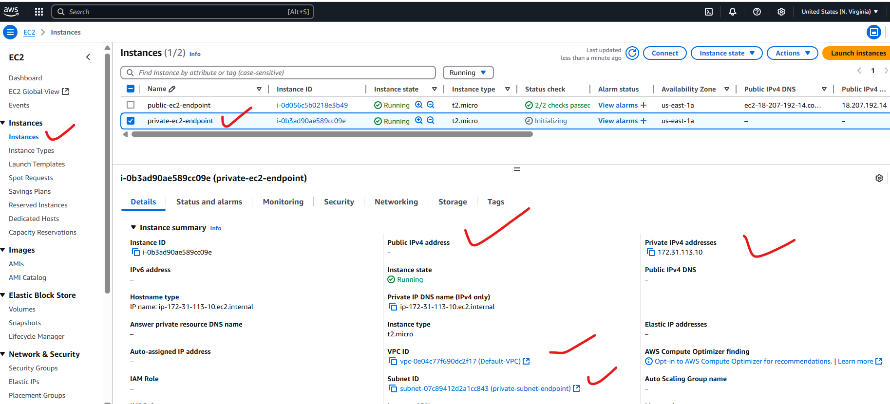

Now I am trying to create s3 bucket:

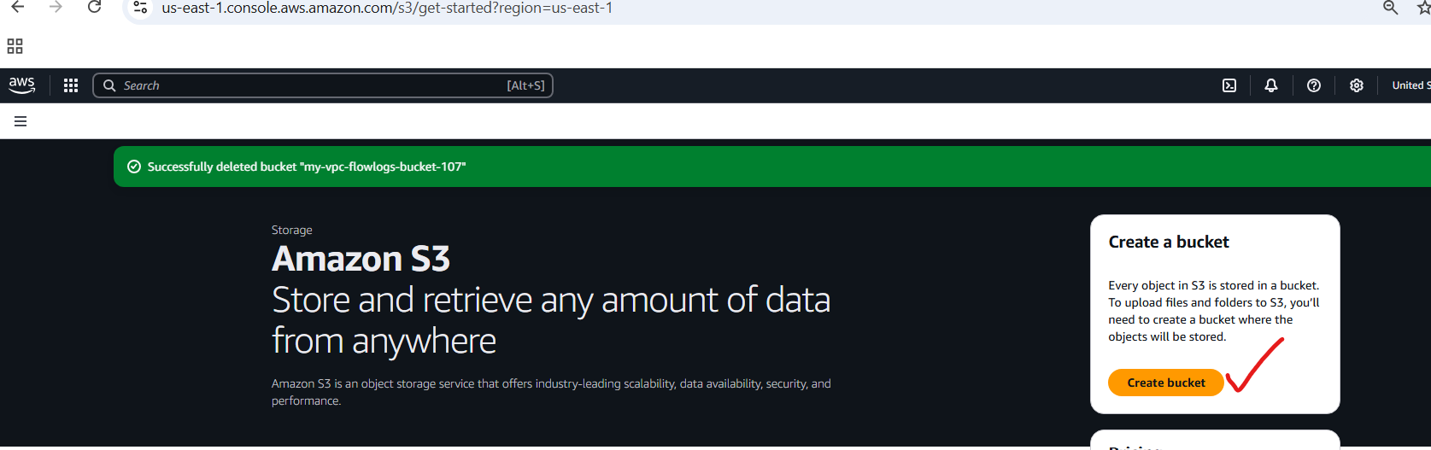

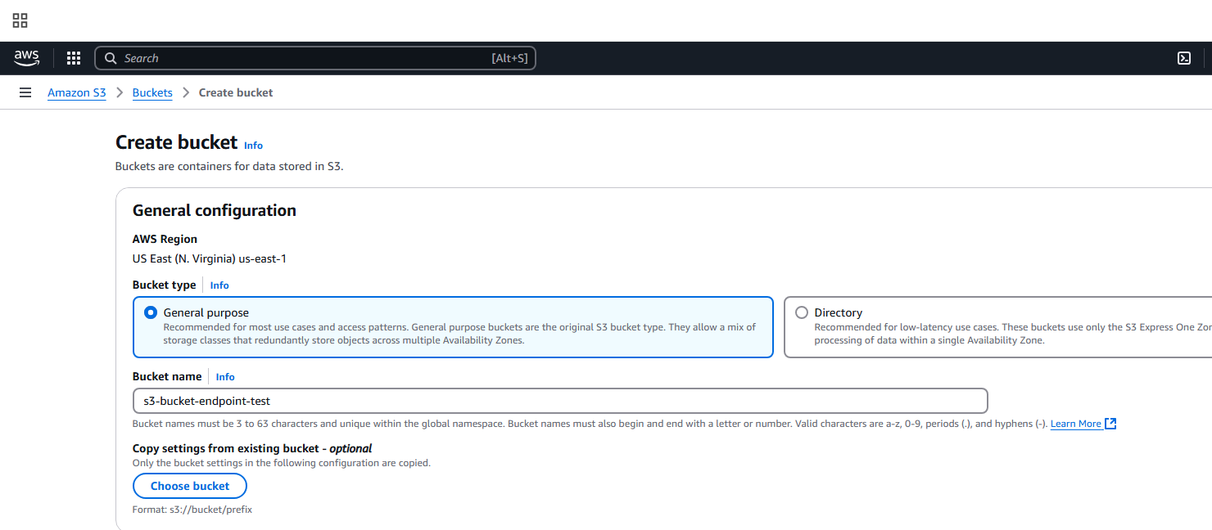

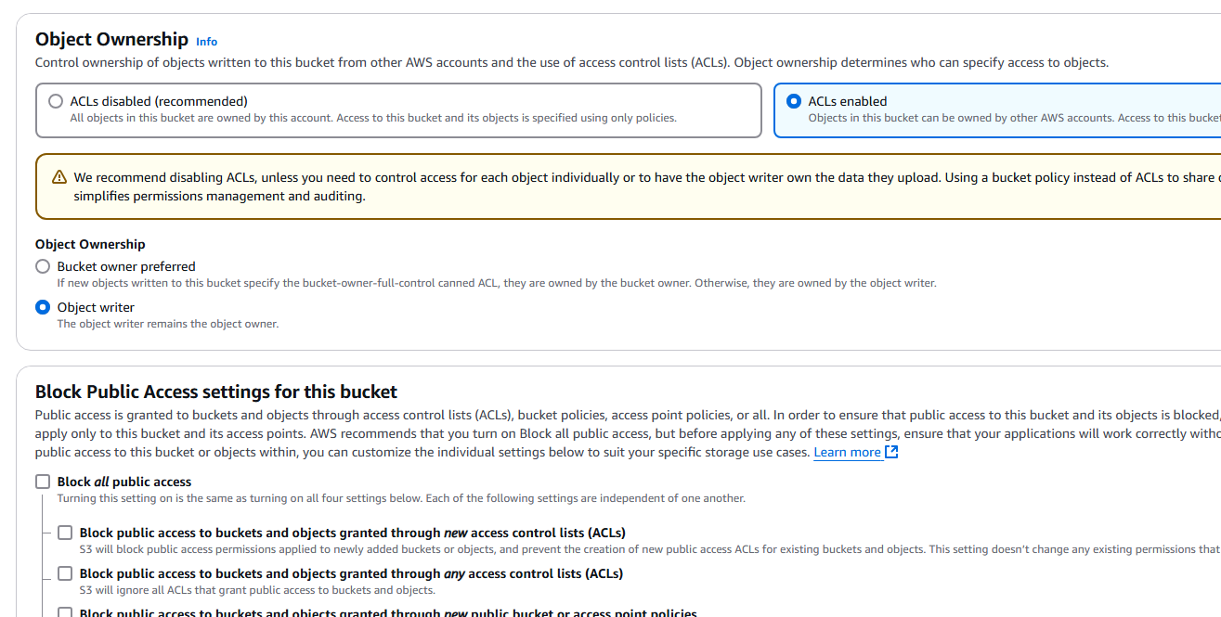

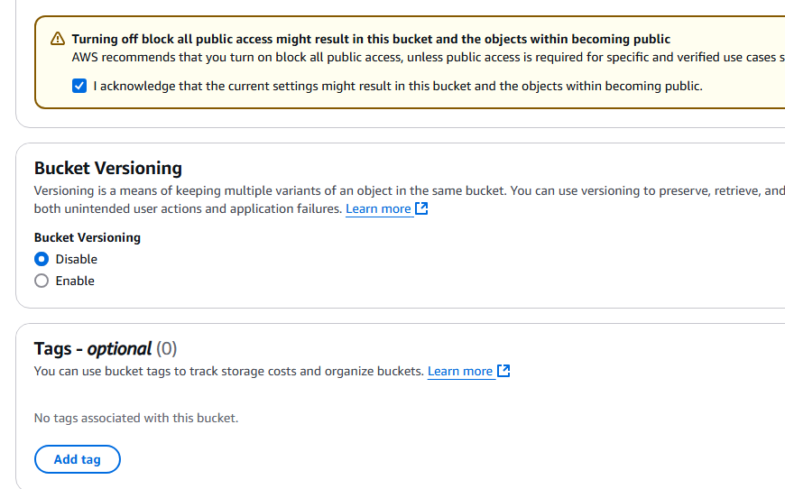

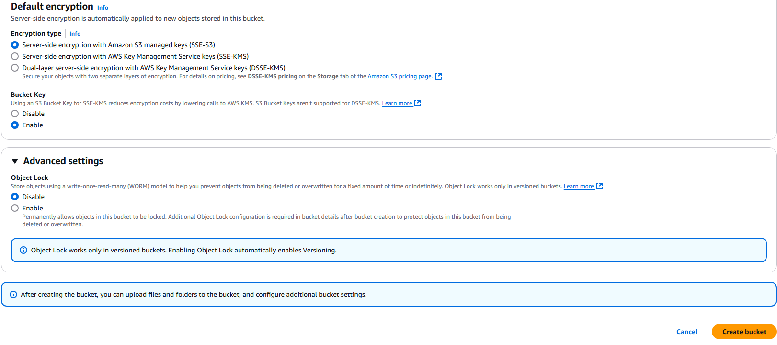

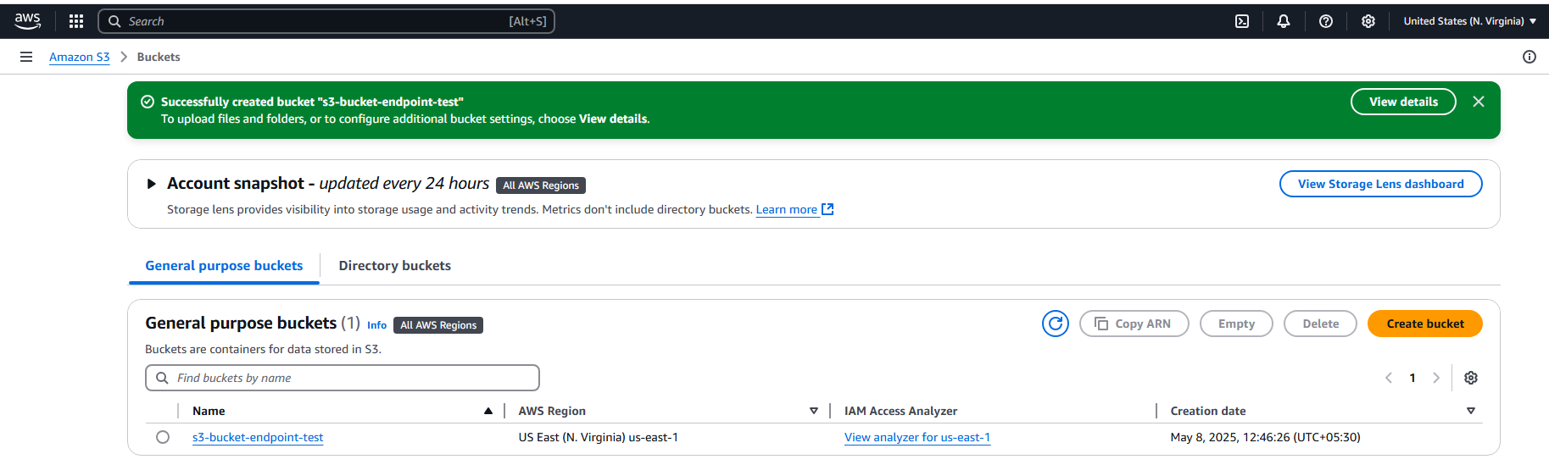

Now go to public-ec2 and connect:

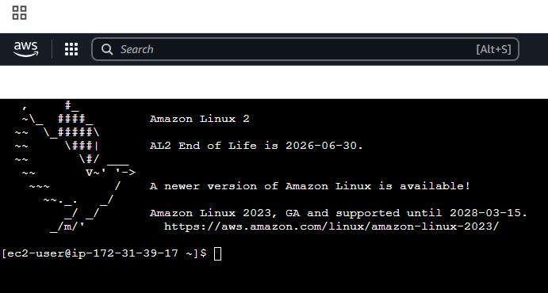

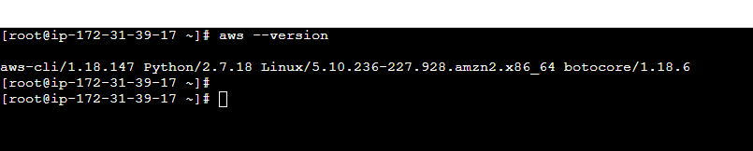

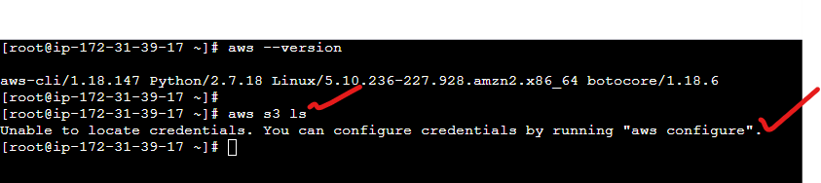

Goto AWS console and Security credentials and take access keys:

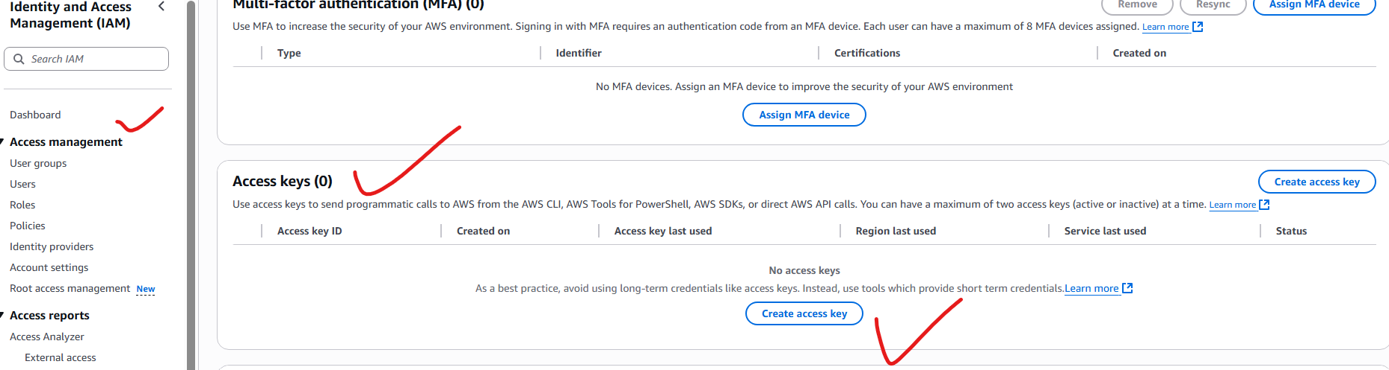

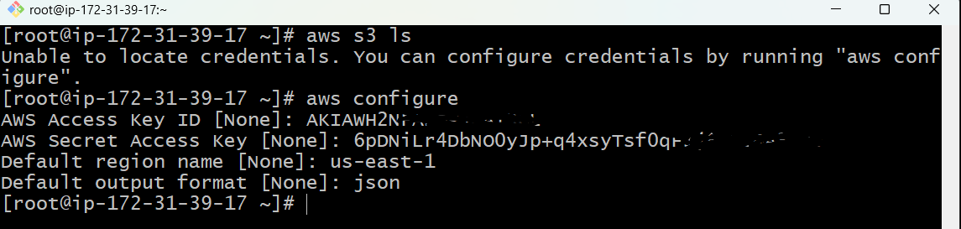

.

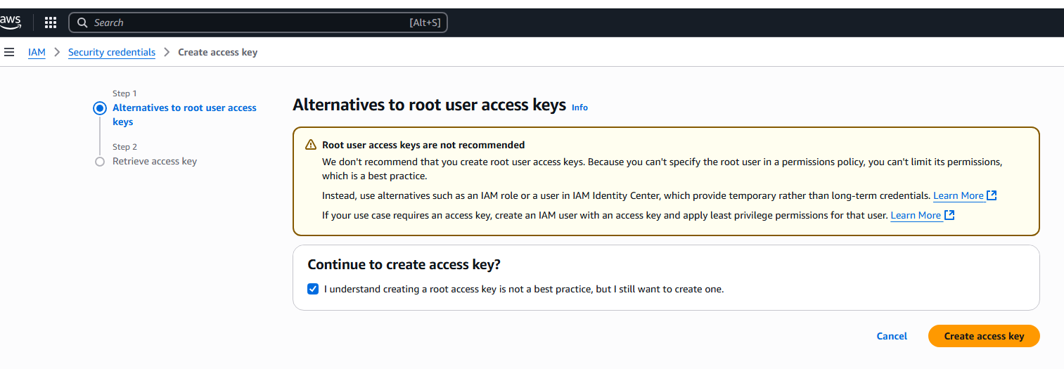

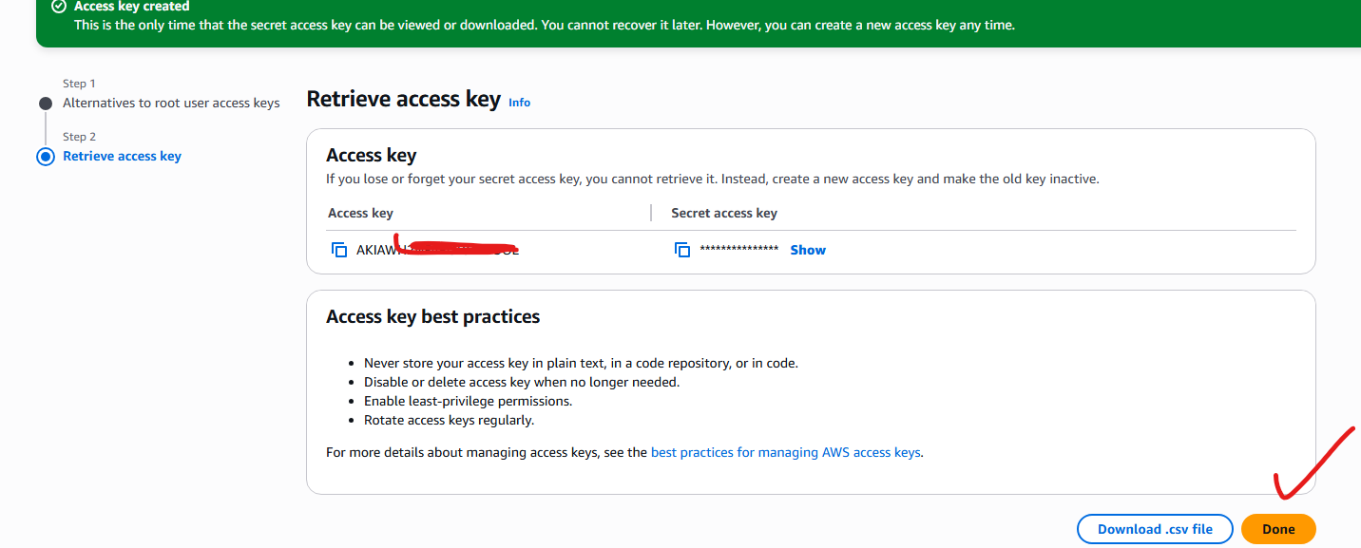

Note: we are accessing to s3 bucket from public ec2 instance because it is connected to network, but I want to accessing to s3 bucket from private ec2 instance, because of not having internet access to private server he cannot access to s3 bucket,

There are ways to connect it, like NAT and etc, but we are trying to connect it from end points

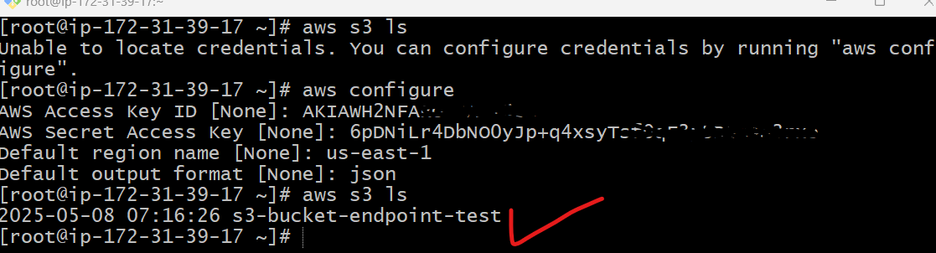

Now I am trying to connect with private ec2 instance:

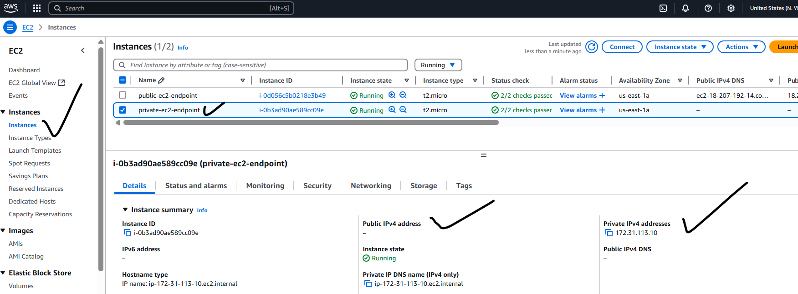

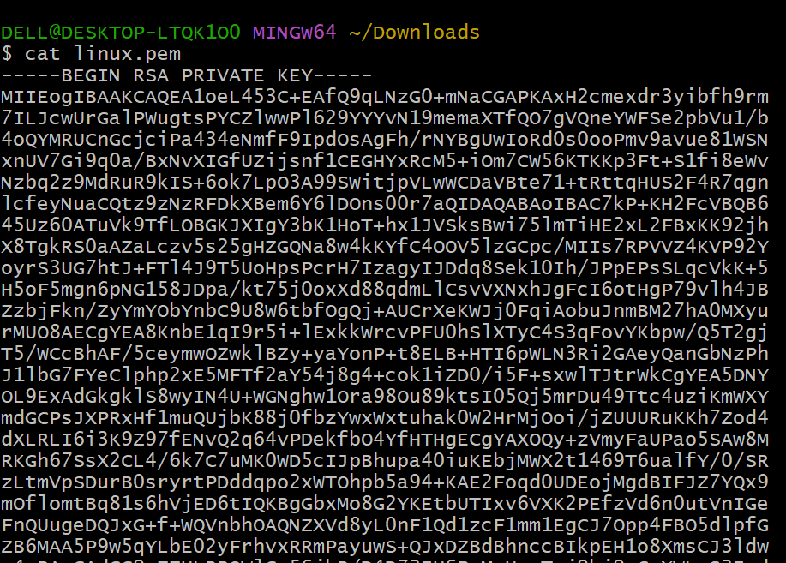

Here connected/login to private ec2 instance from public ec2 instance:

Copy the linux.pem key file details and paste in the files (test.pem)which is created in public ec2 instance as shown below

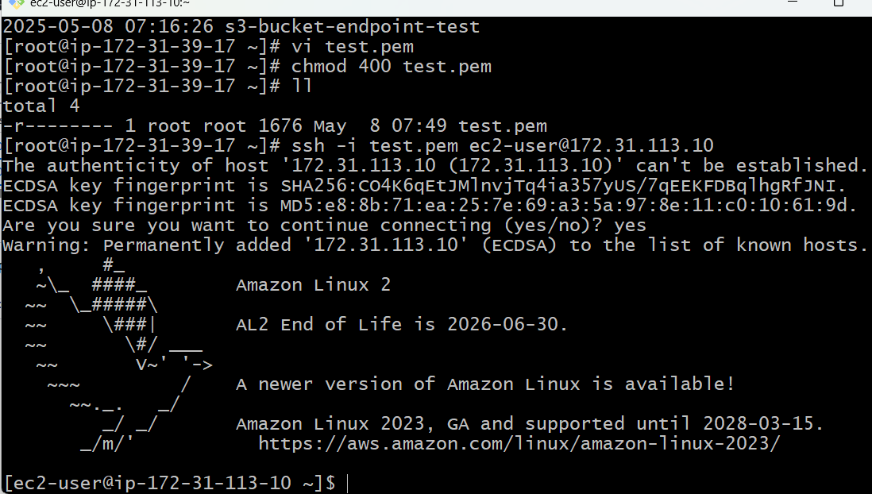

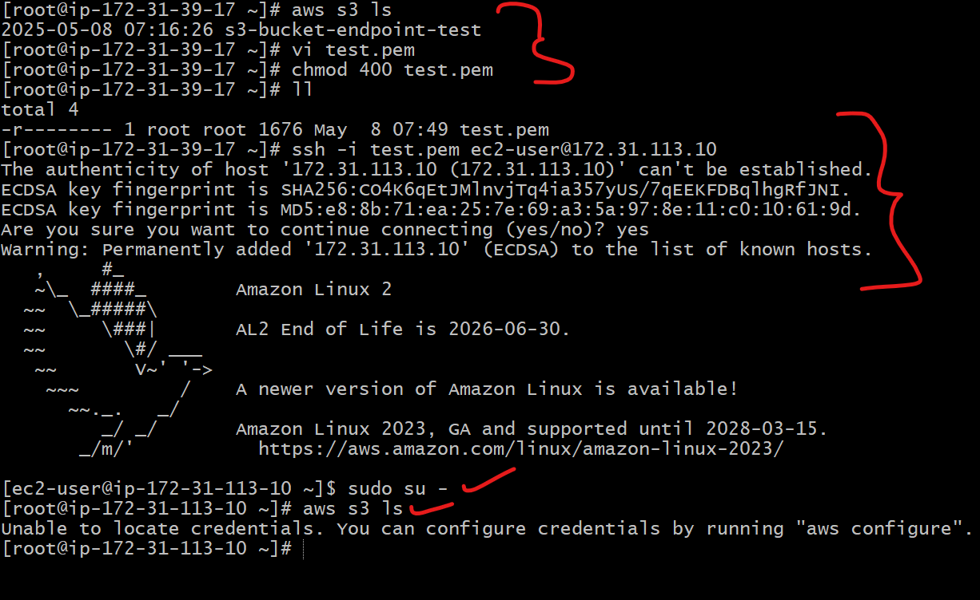

There is no communication between the instance, so it is not getting the s3 details: it will wait for long time but still you wont get any response.

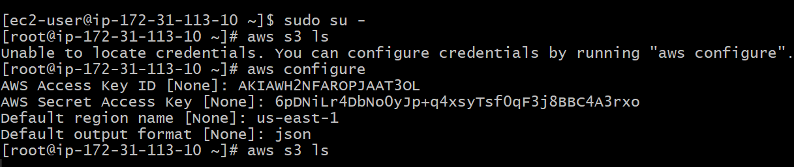

Only one route is available:

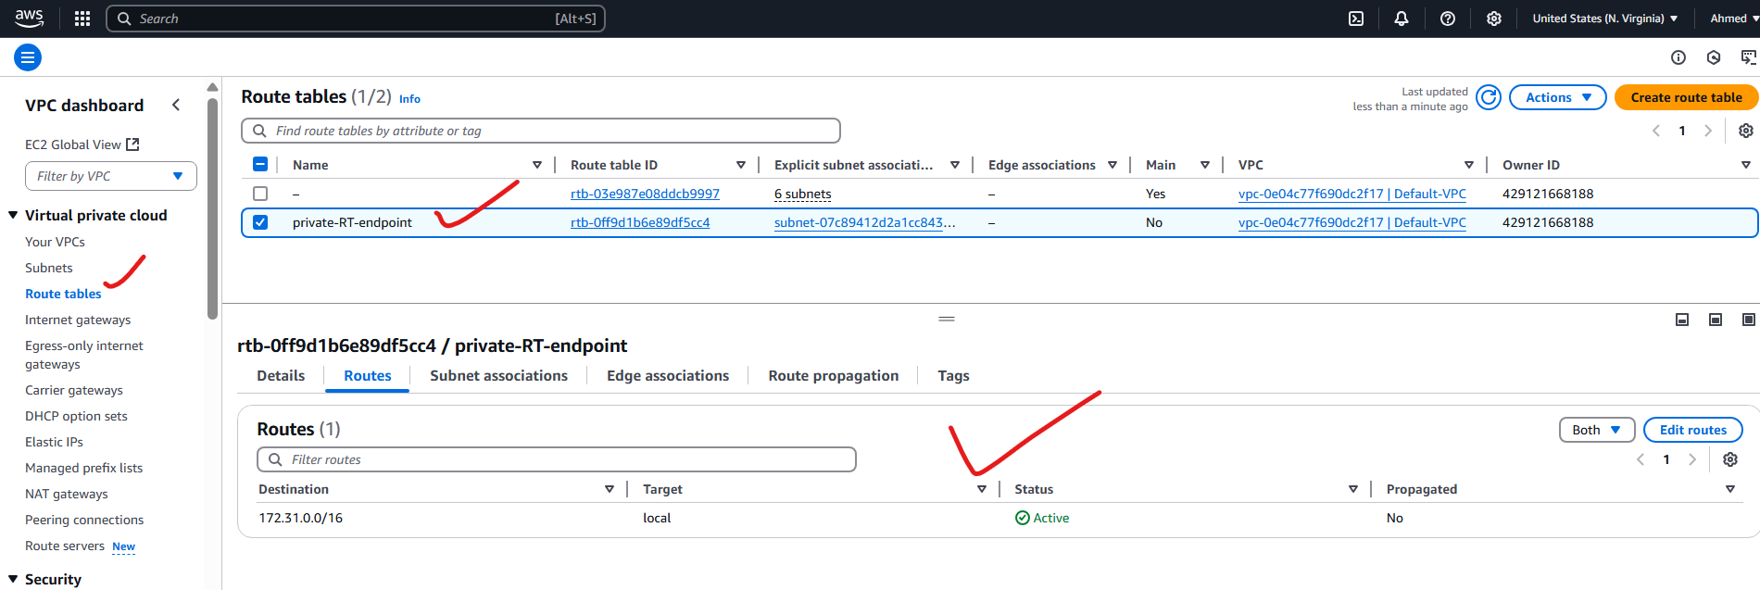

Creating end point: from private subnet

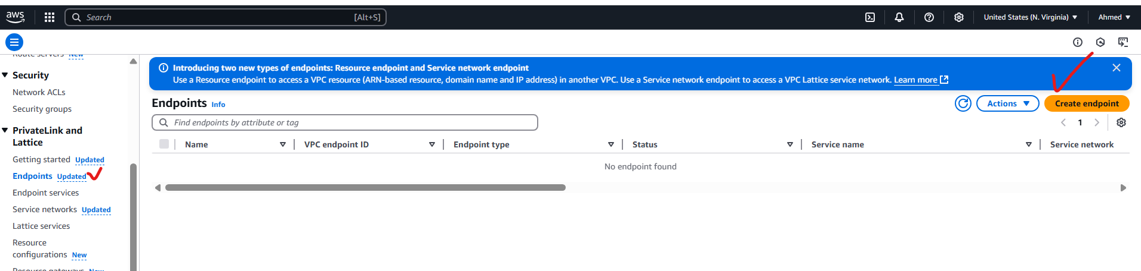

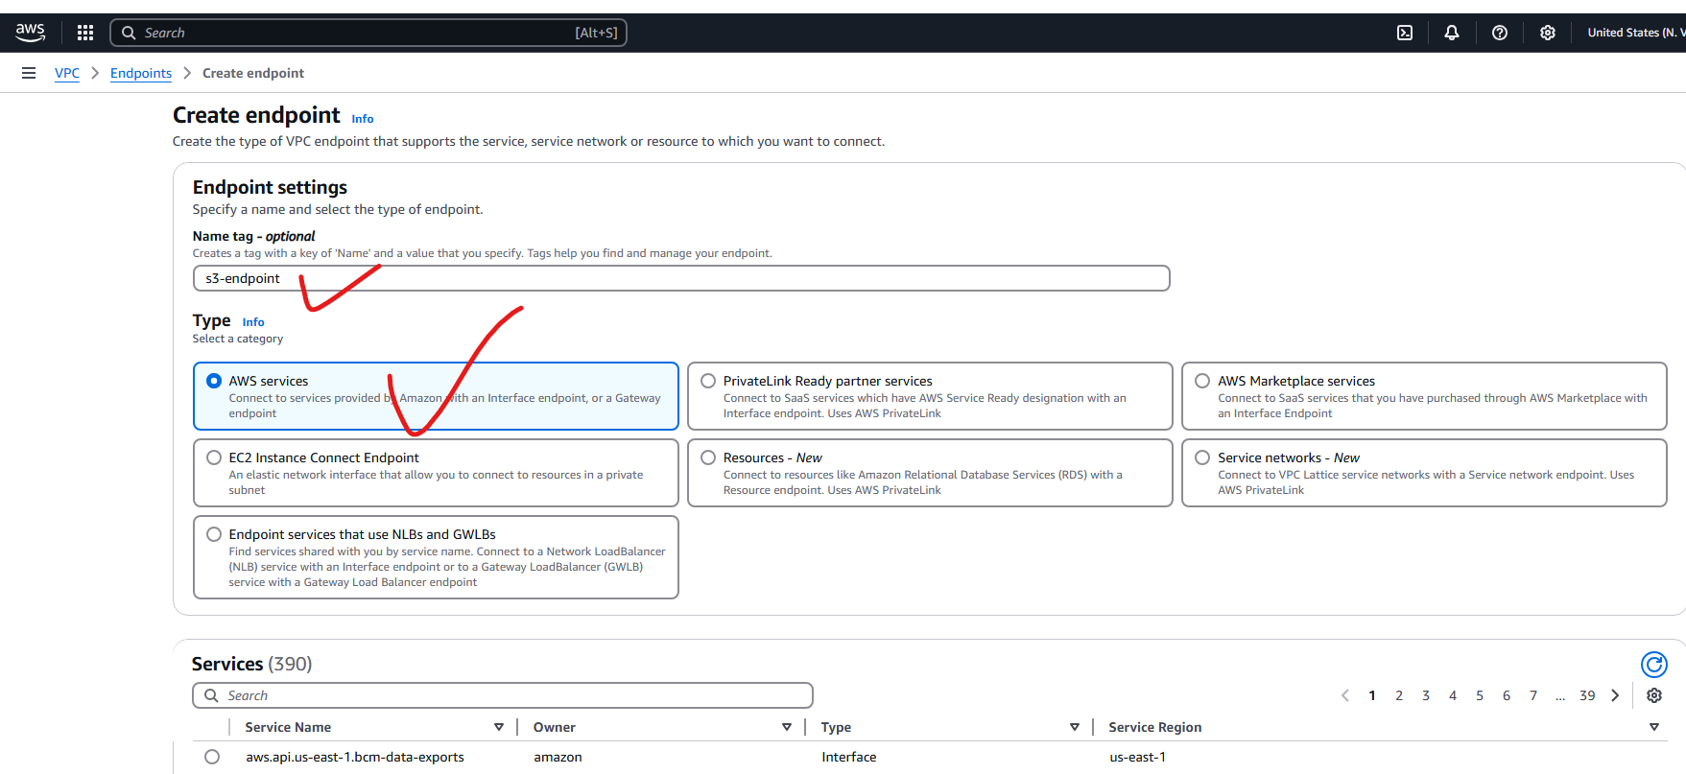

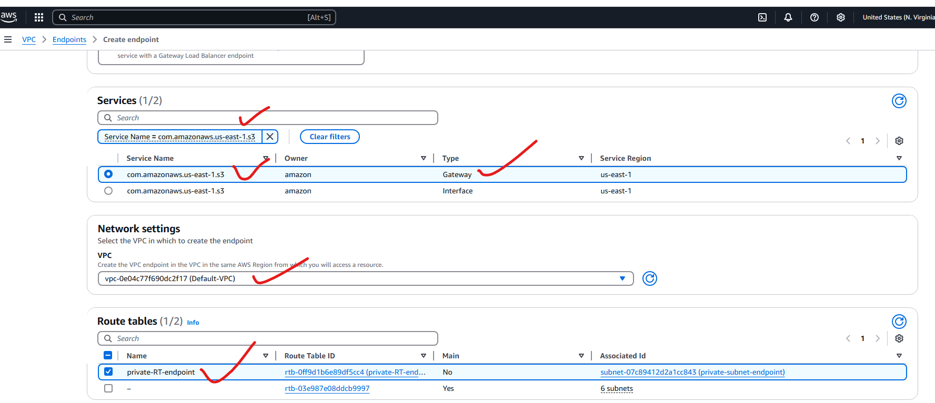

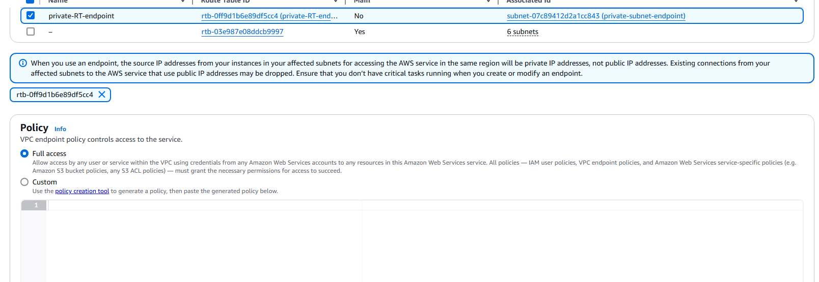

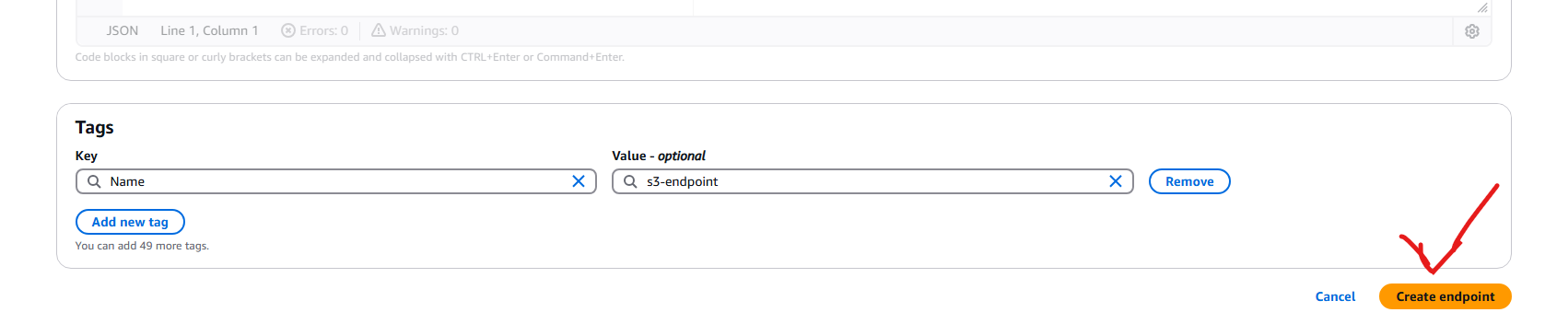

Successfully created vpc endpoint:

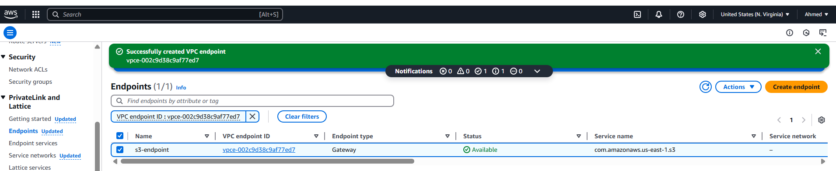

Here one destination as been added automatically from endpoint: which we have created just now.

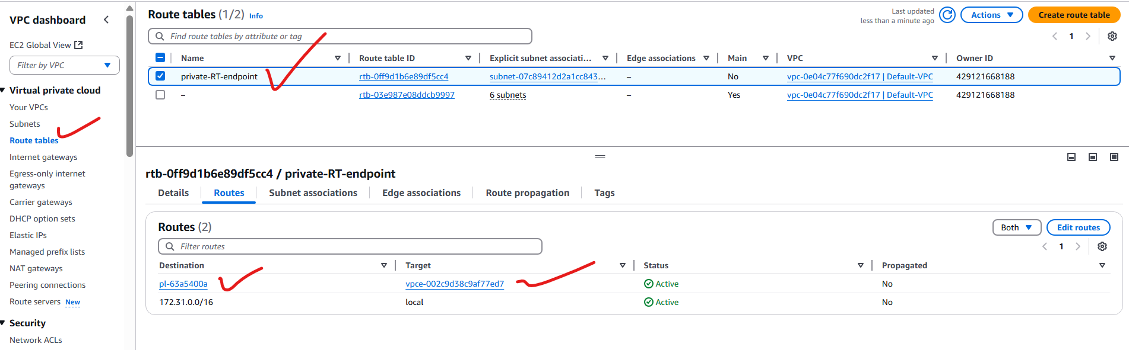

Connected successfully: now private instance can communicate with other services with out internet by using endpoint with in a VPC.

